Practice Guide for the application of the Taking of Evidence Regulation

TABLE OF CONTENTS

1. Introduction – Recitals 1-3 4
1.1. General introduction 4
1.2. Historical background 4
1.3. Need for revision of Regulation 1206/2001 – Recital 1 5
2. Objectives of the Taking of Evidence Regulation – Recitals 3, 4, 7, 21 7
2.1. General introduction – Recitals 3, 4, 7, 21 7
2.2. Purpose of the Practice Guide 7
3. Scope of the Regulation and relationship to other legal instruments – Articles 1, 29 and Recitals 4, 14, 29 8
3.1. Notion of ‘civil and commercial matters’ – Article 1 and Recital 4 8
3.2. Notion of ‘evidence’ 9
3.3. Relations with other instruments – Article 29 and Recitals 14, 29 9
3.4. (Non-)mandatory nature of the Regulation 11
4. Courts, central bodies and other competent authorities – Articles 2(1), 3, 4, 19 and Recital 5 13
5. Electronic transmission of requests and legal effects of electronic documents – Articles 7, 8, 24-28, 31-32, 35, Recitals 7, 9-10, 12-14, 33 16
5.1. Use of electronic transmission and the exceptions – Article 7(1), (4) and Recitals 7, 12 16
5.2. The decentralised IT system – Articles 7, 24-28, 31(4), 35(3), Recitals 7, 9, 10 17
5.2.1. The Implementing Regulation and the Committee – Articles 24, 25 17
5.2.2. e-CODEX – Articles 7, 31(4), 35(3) and Recital 7 18
5.2.3. Reference implementation system and the costs of the decentralised IT system – Articles 27, 28 and Recital 9 19
5.2.4. Accessing the IT system 20
5.2.5. User roles 21
5.2.6. How the IT system works 21
5.2.7. Statistics – Article 32(4) and Recital 33 23
5.3. Legal effects of electronic documents – Article 8 and Recitals 13, 14 24
6. The two methods of taking evidence 25
7. Indirect taking of evidence – Articles 5-18 and Recitals 6, 15-19, 21, 22 27
7.1. Drafting and transmission of requests 27
7.1.1. Form and content – Article 5(1) and Recital 6 27
7.1.2. Languages – Article 6 and Recital 6 30
7.1.3. Exemption of requests from authentication – Article 5(2) 30
7.2. Receipt of requests – Articles 9-10 30
7.2.1. Acknowledgement of receipt – Article 9 30
7.2.2. Incomplete request – Article 10 31
7.3. Taking of evidence by the requested court – Articles 11-15, 22 and Recitals 15, 17-20, 22-23 31
7.3.1. Time limits – Articles 11, 12(1), 22(3) and Recital 15 31
7.3.2. Law applicable to the performance of the requests – Article 12(2)-(3) and Recital 17 31
7.3.3. Coercive measures – Article 15 and Recital 20 32
7.3.4. Performance of the request with the presence and participation of the parties or of representatives of the requesting court – Articles 12(3), 13, 14 and Recitals 18-19 32
7.3.5. Using videoconference for the indirect taking of evidence – Article 12(4) and Recitals 22, 23 33
7.4. Refusal of execution of a request – Articles 1, 10, 16, 22(3) and Recitals 4, 16, 26 34
7.4.1. Right or duty of a person to refuse to give evidence – Article 16 and Recital 16 34
7.4.2. Miscellaneous grounds for refusal – Articles 1, 10, 16(2)(b), 22(3) and Recitals 4, 16, 26 34
7.4.3. No public policy exception 35
7.4.4. Consequences of refusal – Article 16(4) and Recital 16 35
7.5. Follow-up communication – Articles 12(4), 17 and Recital 15 35
7.6. Procedure after the execution of the request – Article 18 35
7.7. Costs – Article 22 35
8. Direct taking of evidence – Articles 19-21 and Recitals 20-25 37
8.1. Direct taking of evidence by the requesting court – Article 19 and Recital 20 37
8.1.1. Request for direct taking of evidence – Article 19(1) and (4) 38
8.1.2. Conditions for the direct taking of evidence reasons for refusal – Article 19(2) and (7) 39
8.1.3. Practical considerations – Article 19(4) and (8) 40
8.2. Direct taking of evidence by videoconferencing or other distance communication technology – Article 20 and Recitals 21-23 40
8.2.1. Request for acceptance – Article 20(1) 41
8.2.2. Conditions for the direct taking of evidence – Article 20(1) 41
8.2.3. Practical considerations – Articles 20(2), 22 and Recitals 22-23 42
8.3. Taking of evidence by diplomatic agents or consular officers – Article 21 and Recital 24 43
9. Rules on the application of modern means of communication and good practice for the use of videoconference 44
9.1. The legal base for the use of videoconference – Articles 12(4), 19, 20, Recitals 20-23 44
9.1.1. Indirect taking of evidence 44
9.1.2. Direct taking of evidence 45
9.1.3. Taking of evidence by diplomatic agents or consular officers 45
9.2. The possibility of using videoconferencing 46
9.3. Practical considerations – Articles 5(1), 20(2) and 21, Recitals 6, 22-24 46
9.3.1. Forms A, L, M, N and content 46
9.4. Follow-up steps to initiate a videoconference 47
9.4.1. Notification or summoning of the witness/expert, presence of parties and/or their representatives 47
9.4.2. Presence of members of the judicial staff for the direct taking of evidence 47
9.4.3. Identification of persons to be examined 48
9.4.4. Further practical information 48
10. Support by contact points of the European Judicial Network in civil and commercial matters (EJN-civil) 49
Annexes 53
Annex I: Correlation table (Articles/recitals of the Taking of Evidence Regulation) 53
Annex II: Correlation table (Articles of Regulation (EC) 1206/2001 – Regulation (EU) 2020/1783) 55
Annex III: CJEU case law on the Taking of Evidence Regulation 58
Annex IV: List of decisions and opinions of the CJEU on the scope of the term ‘civil and commercial matters’ in the EU instruments on private international law 59
Annex V: Guidance on filling in the forms 82
Annex VI: Reference questions and answers 111
A. Practical information 111
B. Special questions on the indirect taking of evidence 115
C. Special questions on the direct taking of evidence 116

Introduction – Recitals 1-3

General introduction
Regulation (EU) 2020/1783 of the European Parliament and of the Council of 25 November 2020 on cooperation between the courts of the Member States in the taking of evidence in civil or commercial matters (taking of evidence) (recast) (the ‘Taking of Evidence Regulation’/ ‘the Regulation’) is a cornerstone of cross-border judicial cooperation in civil matters, alongside the Service of Documents Regulation (). The Taking of Evidence Regulation has a considerable impact in facilitating and streamlining the procedures for taking evidence in a Member State other than the one in which judicial proceedings are or can be brought and significantly reduces the time taken to obtain evidence in another Member State.
Interpretation of the Regulation and the previous Regulation (EC) No 1206/2001 on cooperation between the courts of the Member States in the taking of evidence in civil or commercial matters (‘Regulation 1206/2001’) requires continuity, especially as regards the jurisprudence of the Court of Justice of the European Union (CJEU’), i.e. previous case law in this area remains relevant.
The Regulation and all information relevant for its application (for example the notifications of Member States) are available in the e-Justice Portal (). The portal is an electronic one-stop shop in the area of justice. Among other information on judicial cooperation within the EU, it contains all notifications by Member States on EU Regulations under the keyword ‘European Judicial Atlas in civil matters’ and allows practitioners to search for competent courts and authorities in each Member State.

Historical background
Before 2004, there was no binding instrument between all Member States on the taking of evidence. In 2001, the Council of the European Union adopted Regulation 1206/2001, which mainly entered into application as of 1 January 2004 in accordance with Article 24(2). The model for Regulation (EC) No 1206/2001 was the Hague Convention of 18 March 1970 on the Taking of Evidence Abroad in Civil or Commercial Matters (‘the Evidence Convention’) (), which was replaced by Regulation 1206/2001 in relation to matters to which it applied between the Member States concerned. Regulation 1206/2001 introduced a modern and efficient system of direct communication between courts (transmission of requests and return of evidence taken). It replaced the system whereby requests were transmitted from the court in Member State A to the central authority in Member State B and finally to the court in Member State B where the evidence was to be taken (and vice versa on the way back) as provided for in the Evidence Convention. It also allowed for the direct taking of evidence by the requesting court in other Member States subject to approval by the competent authority of the requested Member State.

Need for revision of Regulation 1206/2001 – Recital 1
Experience of the application of Regulation 1206/2001 showed that communication between competent authorities was mainly paper-based, and the possibility of videoconferencing was used only to a limited extent. In 2018, the Commission therefore put forward a proposal for the revision of the Regulation () that addressed the need for modernisation, in particular digitalisation and the use of modern technology in the cross-border taking of evidence. The Commission’s proposal also reflected the practical problems associated with the application of the Regulation and developments in CJEU case law. The revised Taking of Evidence Regulation was adopted on 25 November 2020, and replaced Regulation 1206/2001 as of 1 July 2022 in accordance with Articles 34 and 35 of the Taking of Evidence Regulation. The requests and other communications provided for in Article 7 are expected to be transmitted by 1 May 2025 through a secure and reliable decentralised IT system based on the e-CODEX interoperable solution (Article 35(3) of the Taking of Evidence Regulation and page 1 of the Annex to Commission Implementation Regulation (EU) 2022/422). The Taking of Evidence Regulation as well as the previous one is applicable throughout the EU except for Denmark (Recital 38) ().

The main new features of the revised Taking of Evidence Regulation compared to Regulation 1206/2001 are the following:
- broader definition of ‘court’ that also includes other authorities of the Member States communicated to the Commission in accordance with Articles 2 and 31(3) of the Taking of Evidence Regulation ();
- the mandatory transmission of requests for cooperation through a secure and reliable decentralised IT system (Article 7 of the Taking of Evidence Regulation), except for exceptions stated in Article 7(4) of the Taking of Evidence Regulation as of 1 May 2025 ();
- promoting use of specific communications technology (such as videoconferencing, teleconferencing) (Articles 12 and 20 of the Taking of Evidence Regulation) ();
- introduction of a specific provision for the taking of evidence by diplomatic agents or consular officers (Article 21 of the Taking of Evidence Regulation) ().

Objectives of the Taking of Evidence Regulation – Recitals 3, 4, 7, 21

General introduction – Recitals 3, 4, 7, 21
The legislation on judicial cooperation in civil and commercial matters has a substantial impact on the everyday lives of EU citizens in their private capacity or business activity. It is applied in judicial proceedings with cross-border implications. Its proper functioning in these specific cases is indispensable in ensuring access to justice and a fair trial for parties to proceedings. Smooth cooperation between courts is also a necessary ingredient for the proper functioning of the single market.

The Taking of Evidence Regulation is an important instrument to facilitate European judicial cooperation in civil and commercial matters between the competent authorities of the Member States to execute requests for the taking of evidence. The Regulation establishes an EU-wide system for the direct and rapid transmission of requests for the taking of evidence between courts and other judicial authorities and the execution of those requests in a speedy manner by providing swift and digitalised procedures. It also lays down precise rules as to the form and content of such requests to ensure greater legal certainty and reduce delays and costs for stakeholders involved in cases in which evidence is taken across borders.

The new Regulation aims to modernise the procedure by simplifying and streamlining the cooperation mechanism and promote electronic communication. This also includes the promotion of videoconferencing, which allows a court to hear people in another Member State by using modern technology.

Purpose of the Practice Guide
This guide is addressed to the ‘users’ of the Regulation, which include mainly courts, central bodies, practitioners and consular agents. It is designed to be a valuable tool to help courts in particular when applying the Regulation. It looks at the various provisions of the Regulation in detail and introduces the individual legislative changes, explaining them by using examples and supplementing them with references to CJEU case law. The guide also gives an overview of the new forms and their use, and includes several annexes that mainly contain correlation tables and lists of case law.

Scope of the Regulation and relationship to other legal instruments – Articles 1, 29 and Recitals 4, 14, 29

Under Article 1(1), the Taking of Evidence Regulation applies in civil or commercial matters where the court () of a Member State, in accordance with the provisions of the law of that state, requests:
- the competent court of another Member State to take evidence; or
- to take evidence directly in another Member State.
Article 1(2) of the Regulation provides that a request ‘shall not be made to obtain evidence which is not intended for use in judicial proceedings, that have already commenced or are being contemplated.’
There are therefore four conditions for the application of the Regulation. It applies to:
- requests for the taking of evidence;
- evidence intended for use in judicial proceedings, commenced or contemplated;
- in civil or commercial matters;
- by the court of a Member State.

Notion of ‘civil and commercial matters’ – Article 1 and Recital 4

The notion of civil and commercial matters is an autonomous concept of EU law that is to be interpreted in the light of the objectives of the Regulation and of the Treaty on the Functioning of the European Union (), and in particular in accordance with Article 81. The CJEU has on different occasions given interpretations of it (). A non-exhaustive list of CJEU case law in relation to the notion of civil and commercial matters is available in Annex IV of this Guide. The Regulation applies to all civil and commercial proceedings irrespective of the nature of the court or tribunal in which they are taking place. It will for instance apply to litigation based on civil and commercial law, consumer law, employment law and even competition law as far as private proceedings are concerned. Moreover, the scope of application of the Regulation may include matters that are excluded from the scope of application of the Brussels Ia Regulation (), for example matters relating to the status or legal capacity of natural persons, matrimonial property regimes, insolvency, maintenance obligations, wills and successions. The Regulation may also apply to civil and commercial matters not covered by an EU instrument at the time of the publication of the Regulation, such as proceedings in the context of the cross-border protection of adults or in the context of adoption.

Notion of ‘evidence’

The concept of evidence is not defined in the Taking of Evidence Regulation. It should be interpreted in a broad manner () and includes for instance hearings of witnesses, parties and experts, the production of documents and verifications, the establishment of facts and expertise on family or child welfare (e.g. social reports or inspection of living conditions) () or extracts on criminal records (). The CJEU found that Regulation 1206/2001 does not apply to a situation where the court of a Member State seeks the address in another Member State of a person on whom a judicial decision is to be served (). However, Article 7 of the Service of Documents Regulation () now provides for the assistance of Member States with address inquiries as of 1 July 2022. The e-Justice Portal contains details on the information provided by the respective Member States ().

The request should be made only to obtain evidence that is intended for use in judicial proceedings that have already commenced or are being contemplated. This includes the taking of evidence before the actual filing of the proceedings in which evidence is to be used, for instance if there is a need to take evidence that would not be available later.

Relations with other instruments – Article 29 and Recitals 14, 29

Article 29(1) of the Taking of Evidence Regulation provides that ‘this Regulation shall prevail in relation to matters to which it applies over other provisions contained in bilateral or multilateral agreements or arrangements concluded by the Member States, and in particular the Evidence Convention, in relations between the Member States party thereto.’

The Taking of Evidence Regulation does, however, not prevent Member States from maintaining or concluding agreements or arrangements between two or more of them to further facilitate the taking of evidence, provided that they are compatible with this Regulation (Article 29(2) of the Regulation). Whether or not Member States have concluded such agreements or arrangements can be established by consulting the notifications of the Member States in the European e-Justice Portal ().

The Taking of Evidence Regulation applies in parallel with many other EU law instruments. Where a court () of a Member State has been seised with proceedings that fall within the material scope of another EU instrument in the field of judicial cooperation in civil or commercial matters and that court – for the purposes of these proceedings – needs to obtain evidence in another Member State, it may use the means provided for by the Taking of Evidence Regulation, but may also use other means it finds appropriate ().

This situation may for instance arise in the context of the Brussels IIb Regulation () if a family court wants to obtain information about the social situation of a child and conduct a hearing of the child who is residing in another Member State. As Recital 39 of the Brussels IIb Regulation clarifies in relation to Regulation 1206/2001, the court of a Member State may, in such a situation, use all means available under national law as well as the specific instruments of international judicial cooperation, including Regulation 1206/2001. This clarification in Recital 39 of the Brussels IIb Regulation should also be transposed to the 2020 Taking of Evidence Regulation. The court may therefore transmit a request for the cross-border taking of evidence under the Taking of Evidence Regulation to the Member State in which the child resides. This would, however, not prevent the court from using the means provided for by the Brussels IIb Regulation. The court could therefore also request a report on the situation of the child under Article 80(1)(a)(i) of the Brussels IIb Regulation (). Whether the court uses the means provided for by the Brussels IIb Regulation or the Taking of Evidence Regulation ultimately remains at the discretion of the court on a case-by-case basis (). This is also reflected in Recital 14 of the Taking of Evidence Regulation. It clarifies that the application of the Regulation does not affect the ability of authorities to exchange information under systems established under other EU instruments such as the Brussels IIb Regulation or the Maintenance Regulation (), even where that information has evidential value. This therefore leaves the choice of the most appropriate method to the requesting authority.

As of May 2025, Article 5 of the Digitalisation Regulation () provides for the participation in a hearing through videoconferencing or other distance communication technology in civil and commercial matters. Where a party or a party’s representative is present in another Member State, the competent authority will decide on their participation in a hearing through videoconferencing or other distance communication technology at the request of a party or their representative or, where provided for under national law, on its own initiative. In that case, it is not necessary to send a request to an authority in the Member State where the party or the representative is present. However, if evidence is sought and the person to be heard is located in another Member State, a request under Article 19 of the Taking of Evidence Regulation has to be filed with the competent authority in that Member State. This might also be relevant where a party is required to give evidence in a pending proceeding (see also Recital 40 of the Digitalisation Regulation).

When it comes to the remote hearing of a child, Recital 39 of the Digitalisation Regulation states that where a child participates in proceedings in civil or commercial matters under national law, in particular as a party, the child should be able to participate in the hearing through videoconferencing or other distance communication technology provided for in the Digitalisation Regulation, taking into account their procedural rights. On the other hand, where the child is participating in the proceedings for the purpose of taking evidence in civil or commercial matters, for example where the child is to be heard as a witness, the child could also be heard through videoconferencing or other distance communication technology in accordance with the Taking of Evidence Regulation.

(Non-)mandatory nature of the Regulation

The CJEU has handed down several decisions on the question of whether the Taking of Evidence Regulation is of a mandatory character, i.e. whether the judicial authorities of a Member State have to take recourse to the procedures provided for by the Regulation when said authorities intend to take evidence in another Member State . The relationship between the new Taking of Evidence Regulation and the previous instrument (Regulation 1206/2001) requires continuity in the interpretation, especially as regards CJEU jurisprudence, i.e. previous case law in this area remains relevant with regard to the Regulation so long as the Regulation does not legislate otherwise.

In its Lippens judgment (), the CJEU considered that the competent court of a Member State that wishes to hear a party residing in another Member State as a witness has the option, in order to perform such a hearing, to summon that party before it and hear them in accordance with the law of its Member State. The court of one Member State that has jurisdiction to hear the substance of the case and wishes to hear a witness residing in another Member State is therefore not required to perform that hearing according to the rules laid down by Regulation 1206/2001.

As far as expert evidence is concerned, the CJEU held in its ProRail judgment () that the court of one Member State that wishes the task of taking of evidence entrusted to an expert to be carried out in another Member State is not necessarily required to use the method of taking evidence laid down by those provisions to be able to order the taking of that evidence. However, the CJEU still considered a request under the Taking of Evidence Regulation necessary when the expert designated by a court of a Member State must travel to another Member State in order to carry out the investigation. Such an investigation might, in certain circumstances, affect the powers of the Member State where it takes place. This is in particular the case where it is an investigation carried out in places connected to the exercise of such powers or in places to which access or other action is, under the law of the Member State in which the investigation is carried out, prohibited or restricted to certain persons (). Judicial authorities may therefore still be obliged to resort to the Taking of Evidence Regulation in order to obtain expert evidence in another Member State if the activity of the experts affects the exercise of state authority.
In C-188/22 (), the CJEU decided for example that a court in a Member State has the right to resort to the written statement of a person residing in another Member State without requesting the direct taking of evidence, especially if the statement is given on a voluntary basis.

Courts, central bodies and other competent authorities – Articles 2(1), 3, 4, 19 and Recital 5

The Taking of Evidence Regulation provides for different courts and authorities:
- the requesting court (Article 3) is the court before which proceedings are commenced or contemplated;
- the requested court (Article 3) is the competent court of another Member State for the performance of the taking of evidence.

Since the adoption of Regulation 1206/2001, the notion of ‘court’ has been broadened in many Regulations (for example the Brussels Ia, Brussels IIb and Successions Regulations ()). The notion of ‘court’ was also extended for the purposes of the Taking of Evidence Regulation. Under Article 2(1) of the Regulation, the notion of ‘court’ therefore means courts and other authorities in Member States as communicated to the Commission under Article 31(3) of the Regulation that exercise judicial functions, that act pursuant to a delegation of power by a judicial authority or that act under the control of a judicial authority and are competent under national law to take evidence for the purposes of judicial proceedings in civil or commercial matters. The notifications of the Member States in this regard can be accessed on the e-Justice Portal; notaries and guardianship authorities, for example, have been communicated by some Member States as other authorities exercising judicial functions (). As a consequence, a notary, guardianship authority or other judicial authority may transmit a request for the cross-border taking of evidence under the Regulation provided that the Member State has communicated the person/authority to the Commission under Article 31(3) in conjunction with Article 2(1) of the Regulation.

The central body (Article 4(1)) supplies information to courts and seeks solutions to difficulties that may arise with a request. The central body forwards – in exceptional cases – at the request of a requesting court a request to the competent court. The efficiency of judicial procedures in civil or commercial matters requires that the transmission and execution of requests for the performance of taking of evidence is made directly and by the most rapid means possible between the courts of the Member States. As a result, a request is transmitted by the central body only exceptionally. For example, such an exceptional case could be the inability to identify the competent court in the court database. Federal Member States, Member States in which several legal systems apply and Member States with autonomous territorial units may designate more than one central body according to Article 4(2) of the Regulation. Furthermore, it is up to the Member States to decide whether the tasks of the central body are exercised by a court or another authority, such as the Ministry of Justice of that Member State ().

The competent authority (Article 4(3)) takes the decisions on requests to take evidence directly under Article 19 of the Regulation. The central body can be designated as being competent for the permission and this is often the case, but this task could also be transferred to a different judicial authority. Member States may designate more than one competent authority to be responsible for taking decisions on requests made under Article 19 of the Regulation.

If a Member State has designated more than one central body/competent authority, then they may only be competent to deal with requests/queries on specific parts of the territory of the Member State.

The names and addresses of the central bodies and competent authorities under Article 4(3) of the Regulation as well as their territorial jurisdiction are to be communicated to the Commission under Article 31(1)(b) and are then published on the European e-Justice Portal ().

The European e-Justice Portal also provides a search tool (European Judicial Atlas in civil matters) that helps to identify the court/authority competent for a specific request. By entering the necessary information (postal code and/or name of city/municipality), the information provided by the Member States can be accessed and the competent authority identified ().

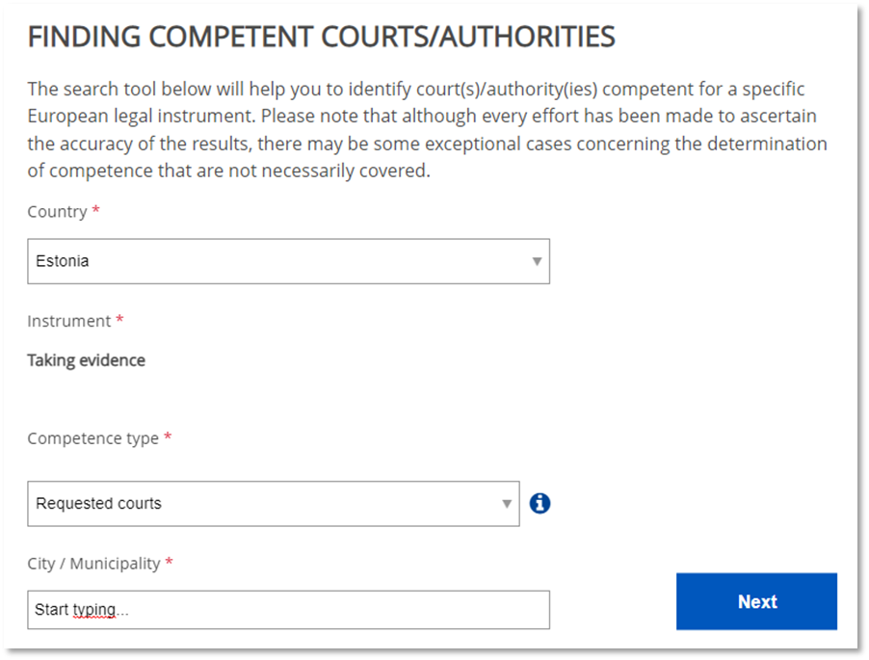
Search tool on the European e-Justice Portal
(https://e-justice.europa.eu/321/EN/european_judicial_atlas_in_civil_matters -> ‘Taking evidence (recast)’)

Electronic transmission of requests and legal effects of electronic documents – Articles 7, 8, 24-28, 31-32, 35, Recitals 7, 9-10, 12-14, 33

The Taking of Evidence Regulation introduces a new way of communication between the competent authorities, namely electronic transmission, to increase efficiency and the speed of cross-border judicial proceedings.
I

Use of electronic transmission and the exceptions – Article 7(1), (4) and Recitals 7, 12
As a rule, the use of a decentralised IT system is mandatory as from 1 May 2025. All communication, transmission of documents and requests between Member States should therefore be carried out via a secure and reliable decentralised IT system designed for the Taking of Evidence Regulation.
However, there are some exceptions to the mandatory use of the IT system:
- The disruption of the IT system. For example, in cases of scheduled maintenance operations of the national IT system (), disruption of internet connection etc.
- The nature of the evidence concerned makes it impossible to use the IT system. For example, the transmission of the requested DNA or blood samples.
- Due to exceptional circumstances when it is more appropriate to use other means of communication. For example, when there is a need for original documents to be in paper format to assess their authenticity or situations in which converting voluminous documentation into electronic form would impose a disproportionate administrative burden on the competent authorities.
If a decentralised IT system is not used, transmission should be carried out by the most appropriate means. To ensure swift and secure transmission, other secure electronic means should be used such as secure email or postal services (Recital 12 of the Regulation).
The exceptions should be interpreted narrowly, on a case-by-case basis and per instance of communication.
Even where the request could not be transmitted through the IT system for one of the reasons mentioned above, it is still recommended to send the request through the IT system as soon as possible with an indication of the sending by other means. This would allow follow-up communication (such as the acknowledgment of receipt and reply) to take place through the IT system unless another exception exists at the time of each follow-up communication.

The decentralised IT system – Articles 7, 24-28, 31(4), 35(3), Recitals 7, 9, 10
The decentralised IT system is an e-CODEX-based system that consists of national IT systems that are interconnected and technically interoperable. The IT system is established for the exchange of documents and messages related to the taking of evidence between the different Member States. The decentralised nature of the IT system enables data to be exchanged exclusively between one Member State and another. The EU institutions are not involved in those exchanges of data and there is no central data repository.
Member States have three choices for connecting to the decentralised IT system (so-called ‘national back-end system’):
- Use software developed by the European Commission (so-called ‘reference implementation software’) and set it up nationally;
- Develop their own software or further develop existing national IT systems; or
- Interconnect the reference implementation software to their national IT system.
Each Member State should determine how the national back-end system is set up – whether there is one national back-end system for all courts and the central body in that Member State, of if there are separate ones for each court and the central body or somewhere in-between.
The date for obligatory use of the IT system is set for 1 May 2025. There is also a possibility for Member States to use the decentralised IT system earlier than required by the Regulation. Member States can use the European e-Justice Portal () to notify their ability to use the IT system earlier.
Follow-up communication concerning requests that were being sent outside the system before 1 May 2025 which takes place as of 1 May 2025 can be sent outside of the decentralised IT system.
However, if both relevant authorities agree, it is possible to include older cases initiated before 1 May 2025 as exceptional cases in the decentralised IT system. In that case the system allows previous communication to be attached to the case. As the forms in the IT system cannot be used due to technical reasons, the dynamic forms would need to be created on the e-Justice Portal and attached to free text messages.
In such situations it is for the authorities to agree on who will initiate the case in the system as an exceptional case.

The Implementing Regulation and the Committee – Articles 24, 25
To establish the decentralised IT system for communication and the exchange of documents, it is necessary to lay down and adopt technical specifications, measures and other requirements for the implementation of that system. To this end the Commission, with the help of the Committee on cooperation between the courts of the Member States in the taking of evidence in civil or commercial matters (‘the Committee’), adopted Implementing Regulation (EU) 2022/422 (), which became applicable on 4 April 2022.

e-CODEX – Articles 7, 31(4), 35(3) and Recital 7
The decentralised IT system is based on the e-CODEX system. The system is a tool specifically designed to facilitate the cross-border electronic exchange of data in the area of judicial cooperation in civil, commercial and criminal matters. The legal framework is established by the e-CODEX Regulation ().
Through its decentralised infrastructure, e-CODEX allows for the electronic exchange of any content transmissible in electronic format, ‘such as text or sound, visual or audio-visual recordings, in the form of either structured or unstructured data, files or metadata’ (). The e-CODEX system deployed by each Member State consists of two main software components:
- a gateway for the secure exchange of messages with other gateways; and
- a connector that provides many functionalities, including connection of the national gateway to the national application, the verification of signatures to ensure that the messages and attachments cannot be manipulated between the sending connector to the receiving connector, semantic interoperability of the exchanged messages and proof of delivery.
To connect to e-CODEX, each Member State has to authorise e-CODEX access points and e-CODEX correspondents who can send and receive technical support ().
e-CODEX is maintained by the European Union Agency for the Operational Management of Large-Scale IT Systems in the Area of Freedom, Security and Justice (eu-LISA) ().

Reference implementation system and the costs of the decentralised IT system – Articles 27, 28 and Recital 9
The Commission is responsible for the creation, maintenance and development of the reference implementation system that is provided to Member States and that they may choose to use as their back-end system instead of a national IT system (Article 27(1) of the Regulation).
The software for the taking of evidence has been developed based on the e-Evidence Digital Exchange System (eEDES). eEDES was developed as a part of a voluntary project where some Member State authorities could securely exchange European investigation orders, mutual legal assistance requests and associated evidence in digital format. eEDES is designed to directly improve the efficiency and speed of existing cooperation procedures, while ensuring the security of exchanges and enabling verification of the authenticity and integrity of transmitted documents. It is also designed to be interoperable with national case management systems (). Given the growth of the IT system, the decentralised IT system (reference implementation and national solutions) under all judicial cooperation instruments that provide for it is now known as the JUstice Digital EXchange system (JUDEX).
The reference implementation system consists of a web portal that authorised users can use to prepare forms and send them to counterparts, and is provided to Member States free of charge.
Each Member State must bear the cost of the installation, operation and maintenance of its access points that interconnect the national IT systems (Article 28(1) of the Regulation).
If Member States use or develop their own national IT system, they will bear the costs of establishing and adjusting their national IT systems to make them interoperable with the access points. This also applies to the maintenance of those systems.
Overall architecture
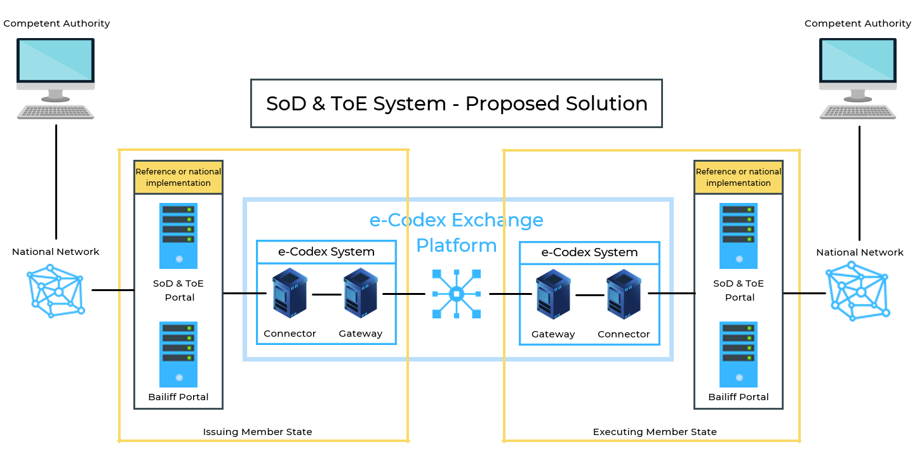
The figure above displays the architecture at national level.
National domains are connected through e-CODEX gateways. The connector is used to ensure that the format of the messages exchanged over the common domain follows a standard European format.
The entry point of the Service of Documents and Taking of Evidence decentralised IT system (SoD & ToE system) is the reference implementation system (RIS) or the national back-end system. The RIS is accessible to Member State users in their national infrastructure. The RIS handles all the workflows and processing required by business transactions. It allows for the exchange and transfer of messages and files between requesting and requested authorities and provides the necessary security level for such exchanges via access control and the end-to-end encryption of the communication.

Accessing the IT system
Only authorised and authenticated users can access the IT system (the SoD & ToE System). There is no public access page. Users will need a configured and enabled Keycloak account to access either the e-Evidence Portal or a national method that will be provided by national representatives. Users who log into the application may perform various functions such as editing forms, filling them in or sending them. As explained above, the IT system is linked to the e-CODEX exchange platform. All exchanges should take place over the e-CODEX exchange platform in a secure manner.

User roles
The IT system (SoD & ToE System) supports role-based access control in order to ensure that access to online data and to the features of the system is limited only to user roles that have been previously granted such access rights. The set of access rights of a given user consists of all the combined access rights of all the roles granted to the respective user. These roles are author, reviewer, sender, supervisor, assigner, dispatcher, guest and statistic handler.

How the IT system works
The exchange of information is based on a message-based approach. There are three groups of messages in the IT system:
- Messages for which a form already exists and is clearly defined. These messages are those based on the forms annexed to the Taking of Evidence Regulation.
- Messages for which a form does not exist, but predefined messages were designed by the Committee to facilitate communication between the competent authorities. The use of these predefined messages is optional.
- Free-text messages with no forms or fields (‘conversation mechanism’). These types of messages can be exchanged at any time in the process between the requesting court, the requested court and the central body when deemed necessary.
It is possible to attach documents and files to each of the three types of messages.
The electronic transmission of a request between the competent authorities through the decentralised IT system consists of different workflows that cover the process under the Taking of Evidence Regulation. The processes were developed with the Committee.
It includes the preparation of the request, its validation, the search for the competent authority and the transmission of the request. There can be a single exchange or multiple exchanges between the courts.
Workflow 1 – Request/reply with direct reply from requested court
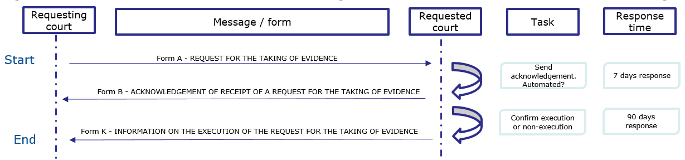
- The requesting court sends a request for taking of evidence with the e-form correctly filled in.
- The requested court receives it: it starts to assess the request to confirm acknowledgement.
- The requested court sends back a receipt notification of the request.
- After sending the confirmation to the requesting court, the requested court prepares the reply.
- The requested court sends back the confirmation of execution or non-execution of the request.

Workflow 2 – Request/reply with deposit or advance request
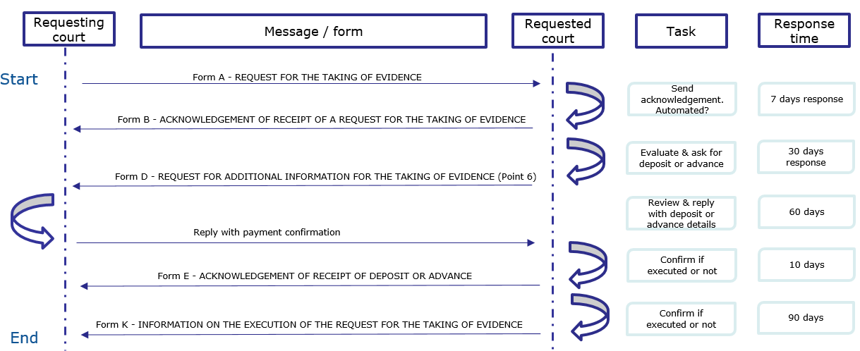
- The requesting court sends a request for taking of evidence with the e-form correctly filled in.
- The requested court receives it: it starts to assess the request to confirm acknowledgement.
- The requested court sends back a receipt notification of the request.
- After sending the confirmation to the requesting court, the requested court asks for a deposit or advance to be made.
- The requesting court reviews and actions the payment request.
- The requesting court sends a reply using the predefined message ‘Reply to request for deposit or advance’ to inform of the payment of the deposit or advance.
- The requested court then acknowledges payment of the deposit or advance.
- The requested court sends back the confirmation of execution or non-execution of the request.
To make the system easier to use and navigate, the Commission has produced a user manual that is available on the e-Justice Portal on the Judicial Atlas and Online Forms pages for Taking of Evidence (recast).

Statistics – Article 32(4) and Recital 33
The RIS programmatically collects the data necessary for monitoring purposes. This data is used to generate statistics. Regardless of whether a Member State chooses to use the RIS or its own national system, the statistics should be provided to the Commission.
The statistics cover mainly the number of exchanges (‘traffic’). Reports are generated based on the logging information. If needed, reports that are more specific or provide more details can also be generated in the RIS. The data generated or collected for logging and audit trail purposes belong solely to the Member States and is under their responsibility.

Legal effects of electronic documents – Article 8 and Recitals 13, 14
To ensure electronic cross-border transmission of documents through the decentralised IT system, the Taking of Evidence Regulation contains a rule on the legal effects of electronic documents that is based on a principle established in the eIDAS Regulation (). Documents that are transmitted through the decentralised IT system should therefore not be denied legal effect and should not be considered inadmissible as evidence in the proceedings solely on the grounds that they are in electronic form. Nevertheless, the assessment of the legal effects or the admissibility of such documents as evidence is left to the national law. The same applies to the conversion of such documents.

The two methods of taking evidence
Chapter II of the Taking of Evidence Regulation contains the rules on the transmission and execution of requests. It provides for two methods of taking of evidence:
- The taking of evidence by the requested court, following a request transmitted directly from the requesting court to the requested court, which is referred to from now on as the indirect taking of evidence (see Chapter 7 of this Guide below). Section 3 of Chapter II of the Regulation provides for the specific provisions on the indirect taking of evidence (Articles 12 to 18 of the Regulation).
- The direct taking of evidence conducted either by the requesting court or by diplomatic agents/consular officers also by videoconference if deemed appropriate by the court (see Chapter 8 of this Guide below). Section 4 of Chapter II of the Regulation provides for the specific provisions on the direct taking of evidence (Articles 19 to 21 of the Regulation).
For the purposes of this guide, the term ‘direct taking of evidence’ refers both to the direct taking of evidence by the requesting court (Articles 19 and 20 of the Regulation) as well as by diplomatic agents or consular officers (Article 21), since in both cases the primary responsibility for the taking of evidence remains with the requesting Member State.
The two methods can be distinguished by which court has primary responsibility over the taking of the evidence procedure:
- For the indirect taking of evidence, this responsibility lies with the court of the requested Member State that conducts the taking of evidence in accordance with the request and subsequently informs the requesting court of the outcome.
- For the direct taking of evidence, the requesting Member State remains in charge of the taking of evidence and conducts the actual taking of evidence itself. Regardless of which means of direct taking of evidence is used (Article 19 or 21), in both cases evidence can be taken through local and distant means (such as through a videoconference).
- In both cases, the Regulation provides for the possibility that the court that does not have primary responsibility over the taking of evidence nevertheless participates in it (see Articles 14 and 19(4)). This could even mean that the court that does not have primary responsibility over the taking of evidence, but participates in it, could ask a witness questions in a hearing if the court with the responsibility over the taking of evidence agrees.

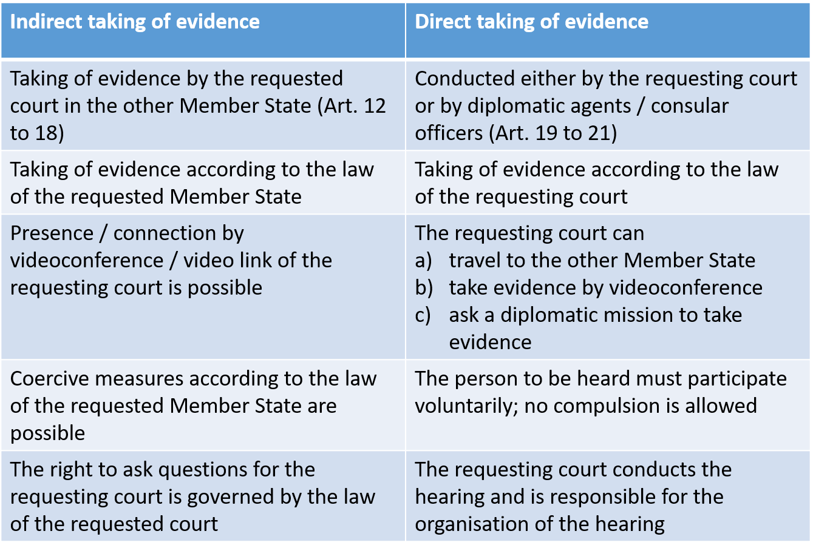

Indirect taking of evidence – Articles 5-18 and Recitals 6, 15-19, 21, 22
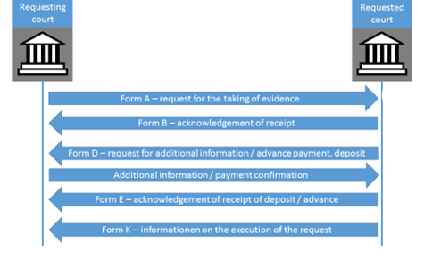
Flow chart illustrating the execution of a request for the indirect taking of evidence, together with Annex I forms (for further details, see below)

Drafting and transmission of requests

Form and content – Article 5(1) and Recital 6
Article 5(1) of the Taking of Evidence Regulation lays down the basic rules on the form and content of a request for the taking of evidence. The request must be made using Form A in Annex I.
It should contain the following details:
(a) the requesting court and, where appropriate, the requested court;
The competent court and the address of that court can be determined by using the search tool as part of the e-Justice Portal (). As of May 2025, when requests have to be transmitted electronically, it is envisaged that the search tool will be integrated into the reference implementation software and the details of the competent court will be entered automatically in the form by the system ().
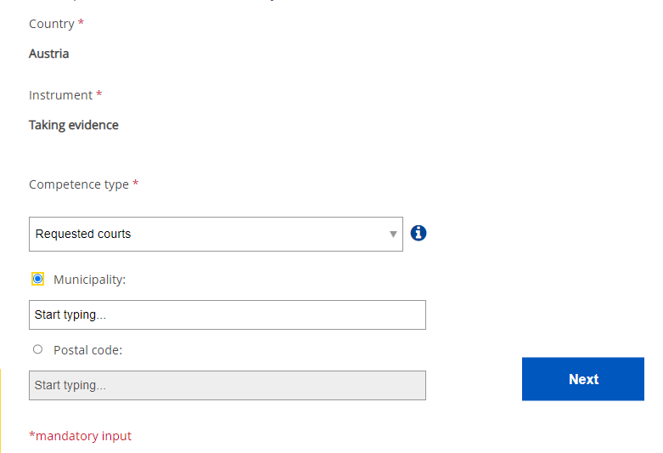
Search tool on the e-Justice Portal

(b) the names and addresses of the parties to the proceedings and their representatives, if any;
(c) the nature and subject matter of the case and a brief statement of the facts;
When completing this field, it may be useful to include with the summary of facts the legal basis of the claim, a short description of the issues in the case and the relevance of the evidence to those issues (point 10 of Form A and/or in an annex to the request). The information should be sufficient for the requested court to determine if the case falls within the scope of application of the Taking of Evidence Regulation. In particular, the information should enable the requested court to establish whether the case pending before the requesting court is to be considered a civil or commercial matter within the meaning of Article 1(1) of the Regulation.
(d) a description of the taking of evidence to be performed (in Form A and/or in an annex to the request);
The level of detail of the description depends on the complexity of the taking of evidence to be conducted. Where the request is e.g. for a DNA sample to be taken, it should provide all the necessary information to ensure that the sample is taken in a way that it can then be properly analysed in the requesting Member State. If a DNA testing kit is provided along with the request, it should be accompanied by detailed instructions.
(e) where the request is for the examination of a person:
- the name(s), address(es) and date of birth (if available) of the person(s) to be examined;
- the questions to be put to the person(s) to be examined or a statement of the facts on which they are to be examined (in Form A and/or in an annex to the request);
- where appropriate, a reference to a right to refuse to testify under the law of the Member State of the requesting court; please cite the relevant national provisions;
- any requirement that the examination is to be carried out under oath or affirmation in lieu of it, and any special form to be used;
- where appropriate, any other information that the requesting court deems necessary.
(f) where the request is for the production of documents or inspection of objects, it should contain their details.
(g) Additionally, if the request should be executed in accordance with a special procedure provided for by the law of the requesting court, it should use Form A as follows:
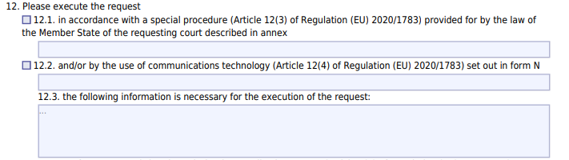
Point 12.1 of Form A allows you to indicate if a special procedure is to be requested pursuant to Article 12(3) of the Regulation.
The details and an explanation of the special procedure should be described in an annex to the form. The special procedure could e.g. cover the manner in which the evidence is to be recorded, or the way a witness is to be examined or the parties are heard, or an expert is appointed and heard or documents are produced.
If the requesting court has asked the requested court to use communications technology for the taking of evidence, in particular by using videoconference and teleconference, Article 5(1)(g) also provides that the request should contain this demand (by selecting Box 12.2 in Form A and by providing the necessary technical information using Form N) ().

Languages – Article 6 and Recital 6
According to Article 6 of the Regulation, the request and any further correspondence are to be drawn up:
- in the official language of the requested Member State;
- if there are several official languages in that Member State, in the official language or one of the official languages of the place where the requested taking of evidence is to take place; or
- in another language that the requested Member State has indicated it will accept.
Documents that the requesting court deems necessary to enclose as an annex for the execution of the request must be accompanied by a translation into the language in which the request was written.
The Member States have communicated the languages they will accept in the e-Justice Portal ().

Exemption of requests from authentication – Article 5(2)
The request and all documents accompanying the request are exempted from authentication or any equivalent formality (Article 5(2) of the Regulation).

Receipt of requests – Articles 9-10

Acknowledgement of receipt – Article 9
The requested court should send an acknowledgement of receipt to the requesting court – using Form B in Annex I – within seven days of receipt of the request (Article 9(1) of the Regulation).
If the request does not comply with the language (Article 6) or transmission rules (Article 7), the requested court should enter a note to that effect in the acknowledgement of receipt (point 6 of Form B).
According to Article 9(2), if the execution of a request that complies with the language rules does not fall within the jurisdiction of the court to which it was transmitted, this court should forward the request to the competent court of its Member State and inform the requesting court about it (using Form C).

Incomplete request – Article 10
There are two cases in which a request cannot be executed because it is incomplete:
- If the request does not contain all of the necessary information under Article 5 (Article10(1) of the Regulation). In this case, the requested court must inform the requesting court about it without delay (at the latest within 30 days of receipt of the request) using Form D, and must ask it to send the missing information, which should be as precise as possible.
- Second, if a deposit or an advance is necessary (Article 10(2)).
If a deposit or advance is necessary, the requested court must inform the requesting court about it without delay (at the latest within 30 days of receipt of the request) using Form D and inform the requesting court how the deposit or advance should be made. The requested court must acknowledge receipt of the deposit or advance without delay (at the latest within 10 days of receiving the deposit or the advance) using Form E (Article 10(2)).

Taking of evidence by the requested court – Articles 11-15, 22 and Recitals 15, 17-20, 22-23

Time limits – Articles 11, 12(1), 22(3) and Recital 15
If the request is complete and can be executed, Article 12(1) of the Regulation stipulates that the requested court must execute it without delay, at the latest within 90 days of its receipt.
If the request cannot be executed because it does not contain all the necessary information under Article 5 or does not comply with the conditions laid down in Articles 6 and 7, the time limit indicated in Article 12 will begin to run only when the requested court has received the request duly completed (Article 11).
If the requested court, before executing the request, has asked the requesting court for an adequate deposit or advance towards the requested costs in accordance with Article 22(3), this time limit will begin to run only when the deposit or the advance is made.

Law applicable to the performance of the requests – Article 12(2)-(3) and Recital 17
In general, the requested court executes the request in accordance with its own law (Article 12(2) of the Regulation). However, it may execute the request under a special procedure provided for by the law of the Member State of the requesting court if the latter so asks in accordance with point 12.1 of Form A. If the requested court is in any doubt about the special procedure requested, it can use Form D to seek additional information.
However, if this procedure of the Member State of the requesting court is incompatible with the law of the Member State of the requested court or because of major practical difficulties, the requested court can refuse to comply with such a requirement (Article 12(3)). A procedure can be considered as incompatible with the law of the Member State of the requested court if it is in conflict with fundamental principles of that law (). In both cases, the requested court must inform the requesting court using Form H.

Coercive measures – Article 15 and Recital 20
The applicable law to coercive measures for executing a request is determined in accordance with the law of the Member State of the requested court to the extent that it provides for the execution of a request made for the same purpose by the national authorities of that Member State or one of the parties concerned (Article 15). However, it should be emphasised that the direct taking of evidence (see Chapter 8) may only take place if it can be performed on a voluntary basis without the need for coercive measures (Article 19(2)).

Performance of the request with the presence and participation of the parties or of representatives of the requesting court – Articles 12(3), 13, 14 and Recitals 18-19
If it is provided for by the law of the Member State of the requesting court, the parties and, if any, their representatives, have the right to be present when the requested court performs the taking of evidence (Article 13(1)).
Representatives of the requesting court have the right to be present when the requested court performs the taking of evidence, if this is compatible with the law of the Member State of the requesting court (Article 14(1)).
The term ‘representative’ of the requesting court means members of the judicial personnel designated by this court in accordance with the law of its Member State or any other person, such as an expert designated by this court.
In its request (Form A, points 8 and 9), the requesting court must inform the requested court that:
- the parties and, if any, their representatives, will be present and, where appropriate, that their participation is requested; or
- the representatives of the requesting court will be present and, where appropriate, that their participation is requested; and
- if either the parties or the representatives of the requesting court require interpretation and if so, into which language it should be arranged.
This information may also be given at any other appropriate time (Articles 13(2) and 14(3)).
If this participation of the parties, or if any of their representatives or of the representatives of the requesting court is requested when the taking of evidence is performed, the requested court determines the conditions under which they may participate, unless this procedure is incompatible with the law of the Member State of the requested court or because of major practical difficulties (Articles 12(3), 13(3) and 14(4)).
Example:
A court in Germany wants to hear a witness in Czechia. The parties have asked to be present when the evidence is taken. The German court also wishes to attend the hearing, which is possible under German procedural law. Both the parties and the German court wish to ask the witness additional questions.
In this case, the requested court has no possibility to hinder the presence of either the parties or the court, but is obliged to inform them of the time and date of the hearing. The court performing the hearing only has the possibility to impose conditions. The Czech court can therefore impose the condition that it will not be possible for the parties to ask the witness additional questions.

The requested court informs the parties and, if any, their representatives, or the requesting court of the time when, and the place where, the proceedings will take place, and, where appropriate, the conditions under which they may participate, using Form I (Articles 13(4) and 14(5)).
If that possibility is provided for by the law of its Member State, the requested court has in any case the possibility of asking the presence and participation of the parties and, if any, their representatives, in the performance of the taking of evidence (Article 13(5)).

Using videoconference for the indirect taking of evidence – Article 12(4) and Recitals 22, 23
The presence and participation of the parties, their representatives and the representatives of the requesting court does not require physical attendance. It is also possible to use long-distance communication technology, in particular videoconferencing. When it comes to hearings in particular, remote attendance using videoconference technology can be used to reduce costs and avoid delays. In order to allow for remote attendance, the requesting court should indicate in Form A (point 12.2) that the request should be executed by the use of communication technology under Article 12(4). It should also attach Form N in order to provide the necessary technical information to establish the video link (or other long-distance communication) ().

Refusal of execution of a request – Articles 1, 10, 16, 22(3) and Recitals 4, 16, 26

Right or duty of a person to refuse to give evidence – Article 16 and Recital 16
Article 16 provides that a request for the hearing of a person should not be executed when the person concerned invokes the right to refuse to give evidence or is prohibited from giving evidence:
- under the law of the Member State of the requested court; or
- under the law of the Member State of the requesting court. In that case, the right must have been specified in the request or, if necessary, been confirmed by the requesting court at the instance of the requested court.

Miscellaneous grounds for refusal – Articles 1, 10, 16(2)(b), 22(3) and Recitals 4, 16, 26
Since the Regulation aims to facilitate the taking of evidence in cross-border cases, the refusal of a request should remain an exception. Whether or not there is an appeal against a refusal is a matter of national law. The grounds for refusal are strictly limited ().
The execution of a request may be refused only if:
- the request does not fall within the scope of the Regulation (Article 1);
- the execution of the request does not fall within the functions of the judiciary under the law of the Member State of the requested court (Article 16(2)(b));
- the requesting court does not comply with the request of the requested court to complete the request under Article 10 within 30 days after the requested court asked it to do so; or
- a deposit or advance asked for in accordance with Article 22(3) is not made within 60 days after the requested court asked for such a deposit or advance.
A requested court must not refuse to execute a request solely on the grounds that under the law of the requested court a court of the same Member State has exclusive jurisdiction over the subject matter of the action or that the law of that Member State would not admit the right of action on it (Article 16(3)).

No public policy exception
Apart from the above exceptions, no public policy (‘ordre public’) exception can be invoked to justify the refusal of the taking of evidence by the requested court().

Consequences of refusal – Article 16(4) and Recital 16
If the execution of the request is refused by the requested court on one of the grounds referred to in Article 16(2), the requested court must notify the requesting court about it within 60 days of receipt of the request using Form K (Article 16(4)).

Follow-up communication – Articles 12(4), 17 and Recital 15
If the requested court is not in a position to execute the request within 90 days of receipt, it must inform the requesting court about it using Form J. When doing so, the grounds for the delay must be given as well as the estimated time that the requested court expects it will need to execute the request (Article 17).
If the requested court has been asked to use communications technology to perform the taking of evidence, in particular by using videoconference and teleconference in accordance with Article 12(4), and if the requested court cannot comply with the demand for one of the reasons provided for in Article 12(4) second indent, it uses Form H to inform the requesting court.

Procedure after the execution of the request – Article 18
When the requested court has executed the request, it sends the documents establishing the execution without delay to the requesting court and, where appropriate, returns the documents received from the requesting court. The documents must be accompanied by a confirmation of execution using Form K (Article 18).

Costs – Article 22
According to Article 22(1), a request for the taking of evidence must not give rise to any claim for the reimbursement of taxes or costs. This means that for example compensation to witnesses is to be borne by the requested court without the possibility of reimbursement. However, fees for experts and interpreters as well as costs that arise due to the use of videoconferencing technology or a special method that has been asked for are to be reimbursed by the requesting court.

Direct taking of evidence – Articles 19-21 and Recitals 20-25

Section 4 of the Taking of Evidence Regulation deals with the direct taking of evidence – the second method of taking of evidence. It allows the court of a Member State, in accordance with its national law, to take evidence directly in another Member State if the request for the direct taking of evidence is accepted by the latter, and under the conditions determined by the central body or competent authority of the requested Member State (Recital 20) ().

Direct taking of evidence by the requesting court – Article 19 and Recital 20

Article 19 indicates the process, conditions and the limits of this method of taking evidence.

The direct taking of evidence by the requesting court could take place by different means and methods. Some examples of the direct taking of evidence:
- hearing of a witness or expert by videoconference (see Chapter 8.2 for more information);
- hearing of a witness by means other than videoconference, such as by telephone;
- a representative of the court travelling to another Member State to get an overview of the living conditions of a child with a parent or guardian in that Member State;
- expert appointed by the requesting court conducting the expertise in the other Member State.

Request for direct taking of evidence – Article 19(1) and (4)

Taking of evidence
DIRECT

CENTRAL BODY/ COMPETENT AUTHORITY
Form L
REQUESTING COURT
Request for direct taking of evidence
Form M MM
Information on whether the request is accepted and whether there are any conditions. The central body may also assign a court in its Member State to assist the requesting court.

Form F
30 days after the acknowledgement of receipt, a reminder may be sent if no reply is received within 15 days of the acknowledgement of receipt of the query request is considered accepted (in exceptional cases it may still be possible to raise grounds for refusal of direct taking of evidence)

The court, which requests to take evidence directly in another Member State, submits its request to the central body or the competent authority designated by the Member State as referred to in Article 4(3) () using Form L (Article 19(1)). The central body or the competent authority and the address of that authority can be determined by using the search tool as part of the e-Justice Portal () or from May 2025 within the decentralised IT system depending on the technical solution used ().
In addition to providing the main identifying information, the form should also include information on the nature and subject matter of the case and a brief statement of the facts (Article 5).
It may be useful to include with the summary of facts the legal basis of the claim, a short description of the issues in the case and the relevance of the evidence to those issues (point 10 of Form L and/or in an annex to the request). The information should be sufficient for the central body or the competent authority to determine if the case falls within the scope of application of the Taking of Evidence Regulation.
Within 30 days of receiving the request, the central body or competent authority must inform the requesting court whether its request has been accepted. The reply is sent using Form M (Article 19(4)). If necessary, the central body or competent authority may also determine under which conditions according to its law such performance is to be carried out (Form M, point 5.2). The conditions laid down may for example be the obligation for the person to be heard in a court room or that the requesting court is obliged to provide an interpreter.
Within Form M there is a possibility for those authorities to assign a court in their Member State to take part in the performance of the direct taking of evidence (Form M, point 6). The court should ensure the proper application of Article 19 as well as the conditions under which the direct taking of evidence is to be carried out are complied with (Article 19(4)). The designated court is the contact point for further communication and it might be also assigned to provide practical assistance in the direct taking of evidence, e.g. videoconferencing, assisting to bring a prisoner to be heard to the court, assisting to arrange meeting rooms or visits to witnesses (Article 19(6)).
For reasons of procedural efficiency, a new rule on implied consent by the central body or competent authority has been inserted in the Regulation. If the court requesting the direct taking of evidence has not received information on the acceptance of the request within 30 days of the acknowledgement of receipt, it may send a reminder (Form F) to the central body or competent authority of the requested Member State. The request is deemed to be accepted if the requesting court does not receive a reply within 15 days of the acknowledgement of receipt of the reminder. In extraordinary circumstances, the grounds for refusal of the direct taking of evidence may exceptionally still be invoked at any time after the expiration of the deadline until the moment of the actual direct taking of evidence (Article 19(5)).

Conditions for the direct taking of evidence reasons for refusal – Article 19(2) and (7)
The direct taking of evidence by the requesting court is only possible if it can be performed on a voluntary basis without the need for coercive measures (Article 19(2)). As a result, where the direct taking of evidence involves the hearing of a person, the requesting court must inform that person that evidence will be taken on a voluntary basis. If the requesting court already knows that the person to be heard is willing to participate, it can be useful to already add this information to the initial request.

The central body or competent authority of the requested Member State may refuse the direct taking of evidence only if (Article 19(7)):
- the request does not fall within the scope of the Regulation (Article 1; see also Chapter 3 of this Guide);
- the request does not contain all of the necessary information under Article 5 (identification of the requesting court, the central body or competent authority, the parties who will take evidence, the nature of the case, description of the taking of evidence) (Form L);
- the direct taking of evidence requested is contrary to fundamental principles of law in its Member State. The Regulation does not define those principles.

Practical considerations – Article 19(4) and (8)
Without affecting the conditions in accordance with the law of the requested Member State (Article 19(4)), the requesting court must execute the request in accordance with its own law (Article 19(8)).
To facilitate the direct taking of evidence, the central body or competent authority of the requested Member State may appoint a court to provide practical assistance (e.g. providing a court room for the videoconference, arranging the connection, identifying the person). This information is given in Form M (point 6).
CJEU case law interpreting Article 17 of Regulation 1206/2001 on the direct taking of evidence should also be taken into account. The ProRail judgment () stating that the court of one Member State that wishes the task of taking of evidence entrusted to an expert to be carried out in another Member State is not necessarily required to use the method of direct taking of evidence. In any event, it may rely on the rules that it considers to be the most effective for the taking of evidence (see Chapter 3.4).

  - Direct taking of evidence by videoconferencing or other distance communication technology – Article 20 and Recitals 21-23
One of the objectives of the Taking of Evidence Regulation is to promote the digitalisation of justice and the use of modern means of communication such as videoconferencing. This is an important means of simplifying and accelerating the procedure of the taking of evidence in the EU. This form of communication is not only useful in standard situations, but is also an appropriate form of communication when people are unable to travel for various reasons. It is therefore the most efficient way to obtain evidence, reduce time and the cost of proceedings.
In general, videoconferencing is used for examining a person such as a witness, a party to the proceeding or an expert present in another Member State. It can be done either in accordance with Article 12(4) when the requesting court asks the requested court to use specific communications technology during the indirect taking of evidence in accordance with its national legal system or when the requesting court wishes to take evidence directly. In the latter case, the rules in Article 19 apply. Moreover, according to Recital 21 videoconferencing can also be used to hear a child as provided for in the Brussels IIb Regulation where the purpose of the hearing is to take evidence. On the other hand, where a child participates in proceedings in civil or commercial matters, in particular as a party, under national law the child should be able to participate in the hearing through videoconferencing or other distance communication technology provided for in Article 5 and Recital 39 of the Digitalisation Regulation (), taking into account their procedural rights. As mentioned above, if the child is to be heard in such a proceeding, the Taking of Evidence Regulation applies and a request has to be sent to the competent authority where the child is located.

Request for acceptance – Article 20(1)
If the evidence is taken by examining a person who is present in another Member State and the court requests the direct taking of evidence in accordance with Article 19, the court should primarily take evidence using videoconferencing or another distance communication technology (Article 20(1)). The court may use any apps or platforms that allow voice or video calls (such as Skype, Teams, WebEx) where it is in accordance with the national law of the Member State requesting the direct taking of evidence. If some practical assistance is needed to organise the videoconference, then the devices, platforms or apps that the assisting court can use should be taken into account when determining which of them to use during the videoconference.
The procedure to request the direct taking of evidence is done in accordance with Article 19 using Form L and marking the tick box p. 12 of that form, together with Form N providing information on technical practicalities for holding a videoconference or using another distance communications technology.

Conditions for the direct taking of evidence – Article 20(1)
The conditions for the direct taking of evidence must be fulfilled in accordance with Article 19 paragraphs 2, 4 and 8. At the same time, modern technology must be available to the court and the court considers the use of such technology to be appropriate in the specific circumstances of the case (Article 20(1)).

Practical considerations – Articles 20(2), 22 and Recitals 22-23
In order to facilitate communication between the competent authorities, and in particular to ensure a successful connection, the requesting court must send the central body or competent authority of the requested Member State or the court assigned practical and technical information for holding a videoconference using Form N. The competent authorities involved in the direct taking of evidence must then agree on the practical arrangements for the examination (Article 20(2) of the Regulation) ().
It is also appropriate to contact the requested authority where the videoconferencing should take place in order to check that the systems are compatible. The preferred date of the test can be indicated in Form N and agreed either through the decentralised IT system or in informal communication (e.g. email, phone call).
Furthermore, upon the request of the requesting court, the court should be assisted by the requested authority in finding an interpreter (including also a certified one) (Recital 22 and Article 20(2)). The requesting court should ensure that the fees paid to experts and interpreters are reimbursed, together with those for the videoconferencing arrangements (Article 22(2), see also Chapter 7.7 of this Guide).
When a request for the direct taking of evidence is accepted, it is the responsibility of the requesting court to organise the videoconference. The court must designate and provide the person or persons to obtain the evidence. The court should provide the parties and their legal representatives with practical information on how to present or other relevant material and inform them that the evidence can only be provided on a voluntary basis (Recital 23).
Chapter 9 of this Guide and the European e-Justice Portal () provide more information on videoconferencing. The European Judicial Network in civil and commercial matters (EJN-civil) has also produced a set of factsheets that provide practical information on rules, procedures and technical facilities for videoconferencing between courts in different EU countries ().
The portal also provides information on how the courts in Member States are equipped with videoconferencing facilities in courtrooms or in special hearing rooms for witnesses and experts ().

Taking of evidence by diplomatic agents or consular officers – Article 21 and Recital 24
In order to speed up the procedure and reduce costs, the Taking of Evidence Regulation introduces (compared to Regulation 1206/2001) the rule on the taking of evidence by diplomatic agents or consular officers. It gives the possibility for national law to provide that their courts may request their diplomatic agents or consular officers, in the territory of another Member State and in the area where they are accredited, to take evidence concerning their nationals and in accordance with the law of their Member State. It must be done under the following conditions: on a voluntary basis without the application of coercive measures at the premises of the diplomatic mission or consulate. The Regulation does not provide for any specific form for such a request to take evidence. The form of communication is left to national law.
The way of requesting the assistance of the diplomatic mission or consulate for the taking of evidence may differ. For example, the court may send a list of questions to be put to the witness by the diplomatic agent or consular officer. The court may be present during the taking of evidence by videoconference or by another distance communication technology.

Rules on the application of modern means of communication and good practice for the use of videoconference
To overcome the distance between the court, the parties, their representatives and any possible witnesses, the Taking of Evidence Regulation provides rules for the taking of evidence by videoconference (). The use of videoconference can reduce time and costs as well as resolve the inability of one or more persons to participate in the proceedings in person. The result of all these factors is more efficient judicial proceedings and increased flexibility for courts in the scheduling of proceedings.
It should be kept in mind that the decision on whether to use videoconferencing is always at the discretion of the court, in particular since its use may not be appropriate in all circumstances. Even then, videoconferencing has become a practical tool used more commonly by courts. The rise in the use of videoconferences is also a consequence of the promotion by and encouragement of the EJN-civil to use it for cross-border cases.
In order to assist those seeking to use videoconferencing when preparing the requests, the courts, the central bodies and competent authorities are encouraged to publish all relevant information about their organisational requirements, booking systems, equipment and technical capabilities. Information is available on the European e-Justice Portal (). The EJN-civil has produced a set of factsheets with practical information on rules, procedures and technical facilities for videoconferencing between courts in different EU countries (). The portal also provides information on whether the courts in Member States are equipped with videoconferencing facilities in courtrooms or in special hearing rooms for witnesses and experts ().

The legal base for the use of videoconference – Articles 12(4), 19, 20, Recitals 20-23
In general, videoconferencing is used to facilitate the presence and/or participation of a person such as a witness, a party to the proceeding or an expert present in another Member State. As outlined in the previous chapters, the use of videoconference is permissible in both the direct and indirect taking of evidence.

Indirect taking of evidence
Under Article 12(4), the requesting court may ask the court in another Member State to obtain evidence for it by using videoconferencing. The requested court is required to execute the request within 90 days of receipt in accordance with the law of its Member State. The parties and/or representatives of the requesting court can be present at the hearing and participate in person or via videoconference. Such participation is allowed under the law of the Member State of the request. It is for the requested court to determine the conditions under which they may participate.
For more information, see Chapter 7.

Direct taking of evidence
A court may wish to obtain evidence directly from a person in another Member State. This can be done in accordance with Articles 19 and 20. In this case, the court obtains evidence under the law of the requesting Member State.
The central body or competent authority of the requested Member State must provide its consent. The central body or competent authority should, within 30 days, inform the requesting court if the request is accepted and, if so, under which conditions.
When a request for the direct taking of evidence is accepted, it is the responsibility of the requesting court to designate and provide the person or persons to obtain the evidence. The direct taking of evidence must be carried out by a member of the judicial personnel or by any other person (expert) designated under the law of the Member State of the requesting court. It is also the responsibility of the requesting court to inform the witness that the evidence can only be provided on a voluntary basis without the use of coercive measures.
For more information, see Chapters 8.1 and 8.2.

Taking of evidence by diplomatic agents or consular officers
The new Regulation introduces the rule on taking of evidence by diplomatic agents or consular officers. The courts have the possibility under national law to request their diplomatic agents or consular officers, in the territory of another Member State where they are accredited, to take evidence concerning their nationals and in accordance with the law of their Member State. It is also recommended and very practical to use videoconferencing for this method of taking of evidence. The Regulation does not provide for any specific form for such a request to take evidence. The form of communication is left to national law.
The taking of evidence must be done on a voluntary basis without the application of coercive measures at the premises of the diplomatic mission or consulate.
For more information, see Chapter 8.3.

The possibility of using videoconferencing
In general, videoconferencing is used for examining a person such as a witness, a party to the proceeding or an expert present in another Member State. Moreover, according to Recital 21 of the Regulation videoconferencing can also be used to hear a child as provided for in the Brussels IIb Regulation where the purpose of the hearing is to take evidence. On the other hand, where a child participates in proceedings in civil or commercial matters, in particular as a party under national law, the child should be able to participate in the hearing through videoconferencing or other distance communication technology as provided for in Article 5 and Recital 39 of the Digitalisation Regulation (), taking into account their procedural rights.

Practical considerations – Articles 5(1), 20(2) and 21, Recitals 6, 22-24

Forms A, L, M, N and content
The Regulation envisages that the competent authorities will use the appropriate forms for communication. The request for the indirect taking of evidence by videoconference should be made using Form A () together with Form N in Annex I. If the direct taking of evidence is made by videoconference, the request is made using Form L () together with Form N in Annex I. The information from the central body or competent authority on the direct taking of evidence is done using Form M () in Annex I.
Communication is a key factor for the hearing by videoconference in all stages of the process. To ensure a successful connection, the requesting court must send practical and technical information for holding a videoconference to the requested court, central body or competent authority of the requested Member State or the court assigned using Form N.
It should contain the following details:
- The reference number and name of the requesting court, and the reference number and name of the requested court.
- Technical details of the requesting court to allow connection between the courts. It is important to provide data for setting up the videoconference (ISDN, IP), for communication the telephone number of the courtroom or any other relevant information such as the technical capabilities of other equipment. If relevant, also the preferred form of connection should be communicated.
- Proposals for dates and times of the connection as well as proposals for dates and times for the test connection to verify interoperability and the proper functioning of the equipment. The concrete dates can be agreed through the decentralised IT system or through informal communication (e.g. email, phone call).
- It is also important to note the responsible person for technical assistance during the test call and the connection and language of communication.
- The requesting court should inform the requested court on whether it needs assistance in finding an interpreter and if yes, between which languages. It is up to the requesting court to ensure that the fees paid to experts and interpreters are reimbursed, together with those for the videoconferencing arrangements.
- The information on whether a recording is required is also sought.
- There might be other important/practical information or clarifications requested by the requesting court from the requested court, such as organisational assistance the requested court may provide, information on the booking system, the initiation, control and ending of the videoconference.

Follow-up steps to initiate a videoconference

Notification or summoning of the witness/expert, presence of parties and/or their representatives
The procedure for notifying or summoning the witness/expert depends on whether the evidence is taken directly or indirectly.
When the request is made to participate in a hearing taking place under Articles 12-14 (indirect taking of evidence), the requested court will make all the necessary arrangements.
When a request for the direct taking of evidence under Article 19 is accepted, it is the responsibility of the requesting court to organise the videoconference. The court must designate and provide the person or persons to give or obtain evidence. It should also provide the parties and their legal representatives with practical information on how they can be present in the taking of evidence and inform them that the evidence can only be provided on a voluntary basis.

Presence of members of the judicial staff for the direct taking of evidence
In Form M point 6, there is a possibility for the central body or competent authority to assign a court of their Member State to take part in the direct taking of evidence. The court should ensure the proper application of Article 19 and that the conditions under which the direct taking of evidence is to be carried out are complied with. The court is the contact point for the requesting court for further communication and to provide practical assistance with videoconferencing.

Identification of persons to be examined
The procedure and conditions for the identification of the witness or expert may vary in each Member State. Similar to court proceedings where evidence is taken in person, the witness or expert may be required to show valid proof of identity (for example passport or ID card) for the purpose of identification in videoconference proceedings.
For the indirect taking of evidence, the requested court conducts the identification of the person to be examined. In contrast, in the direct taking of evidence by videoconference, the identification may be conducted by the requesting court or the court providing practical assistance. In the latter case, a more stringent procedure may be required.
The European e-Justice Portal contains more detailed information.

Further practical information
The European e-Justice Portal contains further practical information such as restrictions for videoconference proceedings, the recording of videoconferences, requirements for taking oaths.
You can find more recommendations that are relevant on videoconferencing in the document European Commission for the Efficiency of Justice (CEPEJ) – Guidelines on videoconferencing in judicial proceedings.

Support by contact points of the European Judicial Network in civil and commercial matters (EJN-civil)
The European Judicial Network in civil and commercial matters (EJN-civil) was established by Council Decision 2001/470/EC () and started operating on 1 December 2002. It is composed of national contact points whose task is to facilitate a smooth and effective functioning of the judicial cooperation taking place within the EU. The contact points offer assistance in many different areas of judicial cooperation in civil and commercial matters. A substantial share of the queries they deal with relate to the cross-border taking of evidence within the framework of the Taking of Evidence Regulation.
The contact points may be approached directly by judicial authorities or practitioners that seek assistance in the context of cross-border cases. Contact details of the national contact points can be accessed via a search tool on the e-Justice Portal (). The assistance provided by the contact points of the Member States is multifaceted and involves among others enquiring about the current status of a request for judicial cooperation (e.g. a request under the Taking of Evidence Regulation), identifying solutions for practical problems arising from a request for judicial cooperation and supplying information that is needed to prepare a request for judicial cooperation.
The EJN-civil does not replace the regular channels of communication for judicial cooperation as provided for by the respective instruments of EU law. As far as the Taking of Evidence Regulation is concerned, the request still has to be transmitted using the channels described in the previous chapters. Solutions for difficulties arising from a request under the Regulation should be provided primarily by the central bodies (Article 4(1) of the Taking of Evidence Regulation) (). The EJN-civil, however, can be seen as an additional source of assistance available to the judicial authorities and practitioners in the Member States, especially when direct communication between them is hampered, for example by language barriers.
The contact points of the EJN-civil meet in person regularly to discuss practical questions and problems arising from judicial cooperation, for example in the context of the Taking of Evidence Regulation. These direct exchanges allow for efficient interpersonal communication and efficient cooperation. The specialised meetings of the EJN-civil that focused on the Taking of Evidence Regulation proved to be very practical. These meetings also include bilateral meetings where contact points can address individual cases of concern.
Furthermore, the EJN-civil publishes and regularly updates information sheets on the national law and procedures of the Member States, including on the taking of evidence and taking of evidence by videoconference. The network also produces practice guides on some instruments, such as this guide ().
Determination of paternity – a practical example of possible assistance by the contact points of the EJN-civil
Proceedings for the determination of paternity are pending before a family court in Germany. The person believed to be the father of the child resides in Sweden. The German court intends to hear the alleged father using videoconference. Furthermore, it needs to obtain a DNA sample from the alleged father to establish paternity.
In such a case, the German court may be facing a variety of practical questions. Questions may already arise while the court contemplates preparing requests for the taking of evidence:
- How do we prepare a request for a direct hearing by videoconference? Are the videoconference systems compatible?
- What should be taken into account when trying to obtain the DNA sample? Is it possible to transmit a DNA testing kit accompanying a request for the indirect taking of evidence?
- Can the requested court in Sweden use coercive measures if the alleged father does not voluntarily cooperate?
In such a situation, the German family court should first check whether the central body can provide the information. If this is not the case, it can then turn to its EJN-civil contact point in Germany. The German contact point will refer to the relevant information available on the e-Justice Portal (e.g. the factsheet on national law with regard to the taking of evidence by videoconference, the European Judicial Atlas etc.). It will then reach out to the Swedish contact point, who will then provide further information, e.g. on what videoconference systems are available, how DNA testing is conducted in Sweden and if the relevant Swedish law provides for coercive measures (Article 15 of the Taking of Evidence Regulation) in such a situation.
Practical questions may also arise at a later stage:
- A request under Articles 19 and 20 of the Taking of Evidence Regulation for a direct hearing of the father through videoconference has been transmitted using Forms L and N, but the practical preparation of the hearing is difficult.
- The execution of the request for the indirect taking of evidence aimed at obtaining a DNA sample from the alleged father is unsuccessful, and the German court needs further information to determine whether to retransmit an amended request.
Where a request is already pending, the contact points can facilitate communication to determine the status of the request and the reasons hindering its execution. The German contact point could therefore ask the Swedish contact point to help with the practical organisation of the videoconference hearing and could ask for a more comprehensive explanation for the failure to obtain a DNA sample from the alleged father.
Taking of evidence – another practical example of possible assistance by the contact points of the EJN-civil

A court sent a request for the taking of evidence to the requested court in another Member State. Although the court sent several reminders and contacted its central body for support, the request remains unexecuted.

In such a case, the court can turn to the EJN-civil contact point in its Member State and ask for assistance in getting information on the status of the request. The contact point will contact their counterpart in the requested Member State. This contact point will inquire about the status of the request at the requested court and will come back to the contact point in the requesting Member State with information about the stage of proceedings. It might also provide information on what is hindering the execution of the request and whether information from the requesting court is missing.

Annexes

Annex I: Correlation table (Articles/recitals of the Taking of Evidence Regulation)

Article(s) | Recital(s) | Topic
- | 1 | Need of recast
- | 2 | Reasons for cooperation in civil maters
- | 3 | General reasons of existence of the Regulation
- | 14 | Non-exclusivity of the Regulation, relationship with Brussels IIb and Maintenance Regulations
- | 14, 21 | Hearing a child within the meaning of Brussels IIb Regulation
- | 34 | Principle of subsidiarity
- | 35 | Consultation of European Data Protection Supervisor
- | 37 | Inclusion of Ireland
- | 38 | Exclusion of Denmark
Article 1 | 4 | Material scope
Article 2(1) | 5 | Definition of ‘court’
Article 2(2) | 7, 8 | Definition of ‘decentralised IT system’
Article 3 | - | Direct transmission between courts
Article 4 | - | Central body
Article 5 | 6 | Form and content of requests
Article 6 | 6 | Language
Article 7(1)-(3) | 7, 8 | Electronic transmission of requests through the decentralised IT system
Article 7(4) | 12 | Impossibility of electronic transmission through the decentralised IT system
Article 8 | 13 | Legal effects of electronic documents
Article 9 | - | Receipt of requests
Article 10 | - | Incomplete requests
Article 11 | - | Completion of the request
Article 12(1) | 15 | Execution of request without a delay
Article 12(2) | 17 | Execution in accordance with national law
Article 12(3) | - | General rules on the execution of a request
Article 12(4) | 22, 23 | Taking evidence by videoconferencing or another distance communications technology
Article 13 | 18 | Taking of evidence with the presence and participation of the parties
Article 14 | 19 | Taking of evidence with the presence and participation of representatives of the requesting court
Article 15 | - | Coercive measures
Article 16 | 16 | Refusals to execute requests
Article 17 | 15 | Notification of delay
Article 18 | - | Procedure after the execution of the request
Article 19 | 20 | Direct taking of evidence by the requesting court
Article 20 | 21, 22, 23 | Direct taking of evidence by videoconferencing or another distance communications technology
Article 21 | 24, 25 | Taking of evidence by diplomatic agents or consular officers
Article 22 | 26 | Costs
Article 23 | 27 | Manual and amendment of Annex I
Article 24 | 27 | Exercise of delegation
Article 25 | 28 | Adoption of implementing acts by the Commission
Article 26 | 28 | Committee procedure
Article 27(1) | 9 | Development of the reference implementation software
Article 27(2) | 10 | Costs of the reference implementation software
Article 28 | 10 | Costs of the decentralised IT system
Article 29 | 29 | Relationship with agreements or arrangements between Member States
Article 30 | 9, 32 | Protection of data
Article 30(2) | 11 | Authorities as controllers of personal data
Article 30(4) | 30, 31 | Protection of confidentiality
Article 31 | 33 | Communication
Article 32 | 33 | Monitoring
Article 33 | 33 | Evaluation
Article 34 | 36 | Repeal
Article 35 | - | Entry into force and application

Annex II: Correlation table (Articles of Regulation (EC) 1206/2001 – Regulation (EU) 2020/1783)

Regulation (EC) No 1206/2001 | Regulation (EU) 2020/1783
Article 1(1) | Article 1(1)
Article 1(2) | Article 1(2)
Article 1(3) | –
– | Article 2
Article 2(1) | Article 3(1)
Article 2(2) | Article 3(2)
Article 3(1) | Article 4(1)
Article 3(2) | Article 4(2)
Article 3(3) | Article 4(3)
Article 4(1) | Article 5(1)
Article 4(2) | Article 5(2)
Article 4(3) | Article 5(3)
Article 5 | Article 6
Article 6 | –Article 7(1)
– | Article 7(2), (3) and (4)
– | Article 8
Article 7(1) | Article 9(1)
Article 7(2) | Article 9(2)
Article 8(1) | Article 10(1)
Article 8(2) | Article 10(2)
Article 9(1) | Article 11(1)
Article 9(2) | Article 11(2)
Article 10(1) | Article 12(1)
Article 10(2) | Article 12(2)
Article 10(3) | Article 12(3)
Article 10(4) | Article 12(4)
Article 11(1) | Article 13(1)
Article 11(2) | Article 13(2)
Article 11(3) | Article 13(3)
Article 11(4) | Article 13(4)
Article 11(5) | Article 13(5)
Article 12(1) | Article 14(1)
Article 12(2) | Article 14(2)
Article 12(3) | Article 14(3)
Article 12(4) | Article 14(4)
Article 12(5) | Article 14(5)
Article 13 | Article 15
Article 14(1) | Article 16(1)
Article 14(2) | Article 16(2)
Article 14(3) | Article 16(3)
Article 14(4) | Article 16(4)
Article 15 | Article 17
Article 16 | Article 18
Article 17(1) | Article 19(1)
Article 17(2) | Article 19(2)
Article 17(3) | Article 19(3)
Article 17(4), first subparagraph | Article 19(4), first subparagraph
Article 17(4), second subparagraph | Article 19(4), second subparagraph
Article 17(4), third subparagraph | –
– | Article 19(5)
– | Article 19(6)
Article 17(5) | Article 19(7)
Article 17(6) | Article 19(8)
– | Article 20
– | Article 21
Article 18 | Article 22
Article 19(1) | Article 23(1)
Article 19(2) | –
– | Article 23(2)
Article 20 | Article 26
– | Article 24
– | Article 25
– | Article 27
– | Article 28
Article 21(1) | Article 29(1)
Article 21(2) | Article 29(2)
Article 21(3)(a) | –
Article 21(3)(b) | Article 29(3)(a)
Article 21(3)(c) | Article 29(3)(b)
– | Article 30
Article 22, first paragraph | Article 31(1)
Article 22, second paragraph | Article 31(2)
– | Article 31(3)
– | Article 31(4)
– | Article 32
Article 23 | Article 33(1)
– | Article 33(2)
Article 24 | –
– | Article 34
Article 24(1) | Article 35(1), first subparagraph
Article 24(2) | Article 35(1), second subparagraph
– | Article 35(2)
 | Article 35(3)
Annex | Annex I
– | Annex II
– | Annex III

Annex III: CJEU case law on the Taking of Evidence Regulation

 | Case number | Names of parties | Referring national court | Date of CJEU decision | Object
Regulation (EC) 1206/2001
1 | C-175/06  (opinion of AG) | Alessandro Tedesco v Tomasoni Fittings Srl and RWO Marine Equipment Ltd | Tribunale Civile di Genova,  Italy | 18.07.2007 (opinion of the AG) | Art 1
2 | C-283/09 | Artur Weryński v Mediatel 4B Spółka z o.o. | Sąd Rejonowy Warszawa, Poland | 17.02.2011 | Art 14,  Art 18
3 | C-170/11 | Maurice Robert Josse Marie Ghislain Lippens and Others v Hendrikus Cornelis Kortekaas and Others | Hoge Raad der Nederlanden, Netherlands | 06.09.2012 | Art 1(1)
4 | C-332/11 | ProRail BV v Xpedys NV and Others | Hof van Cassatie, Belgium | 21.02.2013 | Art 1(1)(b),  Art 17
5 | C-208/20,  C-256/20 | ‘Toplofikatsia Sofia’ EAD and Others | Sofiyski rayonen sad,  Bulgaria | 09.09.2021 | Art 1(1)(a)
6 | C-188/22 | VP v KS | Sąd Okręgowy w Opolu,  Poland | 08.09.2022 | Art 1,  Art 17
Regulation (EU) 2020/1783
7 | C-196/24 | Aucrinde | Tribunal Judiciaire de Chambéry,  France |  | Art 12

Annex IV: List of decisions and opinions of the CJEU on the scope of the term ‘civil and commercial matters’ in the EU instruments on private international law
 | Case number | Names of parties | Referring national court | Date of CJEU decision | Object | Main outcome
1 | 29/76 | LTU Lufttransportunternehmen GmbH & Co. KG v Eurocontrol | Oberlandesgericht Düsseldorf (DE) | 14 October 1976 | Brussels Convention Art 1 | Definition of civil and commercial matters has to be defined by the objective and scheme of the Convention, public acts are excluded from the scope of the Convention.
2 | 133/78 | Henri Gourdain v Franz Nadler | Bundesgerichtshof (DE) | 22 February 1979 | Brussels Convention Art 1(2) | Decisions that derive directly from bankruptcy or winding-up proceedings and are closely connected with the conduct of those proceedings are excluded from the scope of the Convention.
3 | 814/79 | Netherlands State v Reinhold Rüffer | Hoge Raad der Nederlanden (NL) | 16 December 1980 | Brussels Convention Art 1 | Costs being recovered by a public authority (waterway administration) in the exercise of its public competence due to legal liability of a private person do not fall within the scope of the Convention.
4 | C-34/82 | Martin Peters Bauunternehmung GmbH v Zuid Nederlandse Aannemers Vereniging | Hoge Raad der Nederlanden (NL) | 22 March 1983 | Brussels Convention Art 5(1) | Monetary obligations of a member towards a private law association are subject to the contractual rules of the Convention.
5 | C-172/91 | Volker Sonntag v Hans Waidmann, Elisabeth Waidmann and Stefan Waidmann | Bundesgerichtshof (DE) | 21 April 1993 | Brussels Convention Art 1 | Claims for compensation brought before a criminal court fall within the scope of the Convention even though the cover is provided by a public law social security scheme.
6 | C-364/92 | SAT Fluggesellschaft mbH v Eurocontrol | Cour de cassation (BE) | 19 January 1994 | EEC Treaty Articles 86 and 90 | Air control done by an international organisation does not constitute an economic activity.
7 | C-271/00 | Gemeente Steenbergen v Luc Baten | Hof van Beroep te Antwerpen (BE) | 14 November 2002 | Brussels Convention Art 1 | Recourse to a social security payment by a public body falls within the scope of the Convention if governed by ordinary law governing the maintenance obligation. If the recourse is a prerogative of the public body, the situation falls outside the scope.
8 | C-82/01 P | Aéroports de Paris v Commission of the European Communities | Appeal from the General Court (EU) | 24 October 2002 | EEC Treaty Art 86 | Provision of airport facilities constitutes an economic activity.
9 | C-266/01 | Préservatrice foncière TIARD SA v Staat der Nederlanden | Hoge Raad der Nederlanden (NL) | 15 May 2003 | Brussels Convention Art 1 | Guarantee contract between a public body and a private body falls within the scope of the Convention if acts done by the state do not go beyond rules for private individuals.  This also concerns guarantee contracts for a customs debt even if pleas of the guarantor necessitate an investigation into the customs debt.
10 | C-292/05 | Eirini Lechouritou and Others v Dimosio tis Omospondiakis Dimokratias tis Germanias | Efeteio Patron (GR) | 15 February 2007 | Brussels Convention Art 1 | Claims for compensation done by armed forces during the war filed against a foreign state do not fall within the scope of the Convention.
11 | C-435/06 | C | Korkein hallinto-oikeus (FI) | 27 November 2007 | Brussels IIa (2201/2003) Regulation Art 1(1) | Decision ordering a child to be placed in a foster family is a ‘civil matter’ despite being decided in the context of public law.
12 | C-339/07 | Christopher Seagon v Deko Marty Belgium NV | Bundesgerichtshof (DE) | 12 February 2009 | Brussels I (44/2001) Regulation Art 1(2)b  Insolvency  (1346/2000)  Regulation Art 3(1) | Actions to set a transaction aside by virtue of insolvency derive directly from insolvency proceedings, are closely linked to their conduct and therefore fall within the scope of the Insolvency Regulation.
13 | C-523/07 | A | Korkein hallinto-oikeus (FI) | 02 April 2009 | Brussels IIa (2201/2003) Regulation Art 1(1) | Decision ordering a child to be immediately placed outside their original home is a ‘civil matter’ despite being decided in the context of public law.
14 | C-14/08 | Roda Golf & Beach Resort SL | Juzgado de Primera Instancia e Instrucción No 5, San Javier (ES) | 25 June 2009 | Service of Documents (1393/2007) Regulation | The concept of extrajudicial document is a Community law concept. Judicial cooperation is not limited to legal proceedings alone.
15 | C-111/08 | SCT Industri AB i likvidation v Alpenblume AB | Högsta domstolen (SE) | 2 July 2009 | Brussels I (44/2001) Regulation Art 1(2)(b) | Judgments concerning the validity of a transfer carried out by a liquidator in insolvency proceedings derive directly from, and are closely linked to, the conduct of those proceedings and therefore fall outside the scope of the Regulation.
16 | C-292/08 | German Graphics Graphische Maschinen GmbH v Alice van der Schee | Hoge Raad der Nederlanden (NL) | 10 September 2009 | Brussels I (44/2001) Regulation Art 1(2)b  Insolvency  (1346/2000)  Regulation | Actions based on a reservation of title clause do not derive directly from insolvency proceedings and therefore fall within the scope of the Brussels I Regulation, even where the purchaser is insolvent.
17 | C-213/10 | F-Tex SIA v Lietuvos-Anglijos UAB ‘Jadecloud-Vilma’ | Lietuvos Aukščiausiasis Teismas (LT) | 19 April 2012 | Brussels I (44/2001) Regulation Art 1(1) | Only lawsuits closely connected to insolvency are regulated by the Insolvency Regulation, the others (like the one ruled upon concerning lawsuits between the assignee of a claim assigned by a liquidator and a third party) by the Brussels I Regulation.
18 | C-154/11 | Ahmed Mahamdia v People’s Democratic Republic of Algeria | Landesarbeits-gericht Berlin-Brandenburg (DE) | 19 July 2012 | Brussels I (44/2001) Regulation Art 18(2) | Employment at the embassy of a third state can be considered an employment under the Regulation only if it does not concern the exercise of public powers.
19 | C-288/11 P | Mitteldeutsche Flughafen AG and Flughafen Leipzig-Halle GmbH v European Commission | Appeal from the General Court (EU) | 19 December 2012 | EC Treaty Art 87 | Collecting airport fees is a remunerated provision of services and is therefore an economic activity.
20 | C-645/11 | Land Berlin v Ellen Mirjam Sapir and Others | Bundesgerichtshof (DE) | 11 April 2013 | Brussels I (44/2001) Regulation Art 1 | Action for recovery of undue compensation for the victims of expropriation under a totalitarian regime done by a public body falls within the scope of the Regulation.  In this case, the decisive factor was that the obligation to pay the compensation does not depend on whether the owner of the property is a public or private person.
21 | C-49/12 | The Commissioners for Her Majesty’s Revenue & Customs v Sunico ApS and Others | Østre Landsret (DK) | 12 September 2013 | Brussels I (44/2001) Regulation Art 1 | Claim for damages for loss caused by a tortious conspiracy to commit VAT fraud in another Member State filed by a tax authority of that Member State in a different Member State falls within the scope of the Regulation.  In this case, the claim was done under tort law, not under tax law as the defendants were not subject to VAT rules in the UK.
22 | C-92/12 | Health Service Executive v S.C., A.C. | High Court (IE) | 26 April 2012 | Brussels IIa (2201/2003) Regulation Art 1 | Judgment ordering the placement of a child in a secure institution situated in another Member State where the child is deprived of liberty falls within the scope of the Regulation.
23 | C-157/13 | Nickel & Goeldner Spedition GmbH v ‘Kintra’ UAB | Lietuvos Aukščiausiasis Teismas (LT) | 4 September 2014 | Brussels I (44/2001) Regulation Art 1(1) | To determine whether a lawsuit is closely related to insolvency proceedings that bring the case outside the scope of the Regulation, it should be considered whether the insolvency rules deviating from standard applicable laws are applicable in the case.
24 | C-226/13, C-245/13, C-247/13, C-578/13 | Stefan Fahnenbrock and Others v Hellenische Republik | Landgericht Wiesbaden (DE) | 11 June 2015 | Service of Documents (1393/2007) Regulation Art 1(1) | The fact that sovereign bonds are issued pursuant to a law does not mean the associated claims are automatically not civil or commercial as even private parties issue bonds. It is important that public powers are not associated.
25 | C-302/13 | flyLAL-Lithuanian Airlines AS v Starptautiskā lidosta Rīga VAS and Air Baltic Corporation AS | Augstākās Tiesas Senāts (LV) | 23 October 2014 | Brussels I (44/2001) Regulation Art 1 | Claims for damages arising from a violation of EU competition law fall under the scope of the Regulation.
26 | C-4/14 | Christophe Bohez v Ingrid Wiertz | Korkein oikeus (FI) | 9 September 2015 | Brussels IIa (2201/2003) Regulation Art 1, Brussels I (44/2001) Regulation Art 1 | Enforcement of a penalty payment concerning custody rights is subject to the scope of the Brussels IIa Regulation.
27 | C-223/14 | Tecom Mican and Arias Domínguez | Juzgado de Primera Instancia No 7 de Las Palmas de Gran Canaria (ES) | 11  November 2015 | Service of Documents (1393/2007) Regulation | The term of extrajudicial documents contains documents produced by a non-public authority, i.e. a private person, which is necessary to exercise, prove or safeguard a right or a claim.
28 | C-359/14, C-475/14 | ‘ERGO Insurance’ SE v ‘If P&C Insurance’ AS and ‘Gjensidige Baltic’ AAS v ‘PZU Lietuva’ UAB DK  . | Vilniaus miesto apylinkės teismas and Lietuvos Aukščiausiasis Teismas (LT) | 21 January 2016 | Rome I (593/2008)  Regulation  Rome II (864/2007)  Regulation | Actions for indemnity between insurers following a road traffic accident fall within the scope of the Rome II Regulation, while the insurer’s obligation to compensate the victim is governed by the Rome I Regulation.
29 | C-404/14 | Marie Matoušková | Nejvyšší soud (CZ) | 6 October 2015 | Brussels IIa (2201/2003) Regulation Art 1(1)(b) | Approval of an agreement for the sharing out of an estate concluded by a guardian ad litem on behalf of a child falls within the scope of parental responsibility, pursuant to the Brussels IIa Regulation Art 1(1)(b).
30 | C-523/14 | Aannemingsbedrijf Aertssen NV and Aertssen Terrassements SA v VSB Machineverhuur BV and Others | Rechtbank Gelderland (NL) | 22 October 2015 | Brussels I (44/2001) Regulation Art 1 | Claims for damages caused by a criminal act if the object is to obtain monetary compensation fall under the scope of the Regulation even if they are part of the criminal proceedings.
31 | C-102/15 | Gazdasági Versenyhivatal v Siemens Aktiengesellschaft Österreich | Fővárosi Ítélőtábla (HU) | 28 July 2016 | Brussels I (44/2001) Regulation Art 1 | Claims for unjust enrichment against a competition authority for excessive fines do not fall within the scope of the Regulation.
32 | C-191/15 | Verein für Konsumenteninformation v Amazon EU Sàrl, | Oberster Gerichtshof (AT) | 28 July 2016 | Rome I (593/2008)  Regulation Art. 1(3) and 6(2)  Rome II (864/2007)  Regulation Art. 1(3) and 6(1) | In actions for injunctions against the use of unfair contractual terms, obligations aimed at protecting consumers fall within the scope of the Rome II Regulation, while the assessment of contractual terms themselves always falls within the scope of the Rome I Regulation, regardless of the collective or individual nature of the action.
33 | C-215/15 | Vasilka Ivanova Gogova v Ilia Dimitrov Iliev | Varhoven kasatsionen sad (BG) | 21 October 2015 | Brussels IIa (2201/2003) Regulation Art 1 | An action in which one parent asks the court to remedy the lack of agreement of the other parent to their child travelling outside their residence concerning the issuance of a passport for that child falls within the scope of the Regulation despite the fact that the decision will be taken into account by administrative authorities issuing the passport.
34 | C-294/15 | Edyta Mikołajczyk v Marie Louise Czarnecka, Stefan Czarnecki | Sąd Apelacyjny w Warszawie (PL) | 13 October 2016 | Brussels IIa (2201/2003) Regulation Art 1(1)(a) | Action for annulment of marriage brought by a third party following the death of one of the spouses falls within the scope of the Regulation.
35 | C-551/15 | Pula Parking d.o.o. v Sven Klaus Tederahn | Općinski sud u Puli-Pola (HR) | 9 March 2017 | Brussels Ia (1215/2012) Regulation Art 1 | Claims by a public authority for recovering parking fees not paid to a company that has been delegated by the public authority to operate a car park fall within the scope of the Regulation if they are not of a punitive nature as they are basically claims for the provision of services.
36 | C-218/16 | Kubicka | Sąd Okręgowy w Gorzowie Wielkopolskim (PL) | 12 October 2017 | Succession (650/2012)  Regulation  Art 1(2)(k) and (l) and Art 31 | The material effects of a legacy by vindication governed by the law applicable to the succession fall within the scope of the Regulation.  The refusal by a Member State to recognise those effects is precluded, even where such a mechanism is unknown in its legal system.
37 | C-372/16 | Soha Sahyouni v Raja Mamisch | Oberlandesgericht München (DE) | 20 December 2017 | Rome III (1259/2010) Regulation Art 1 | Only divorces pronounced either by a national court or by, or under the supervision of, a public authority fall within the scope of the Regulation. Unilateral declarations before a religious court fall outside the scope.
38 | C-558/16 | Doris Mahnkopf v Sven Mahnkopf | Kammergericht Berlin (DE) | 1 March 2018 | Succession (650/2012)  Regulation  Art 1(1) | National provisions prescribing, on the death of one of the spouses, a fixed allocation of the accrued gains by increasing the surviving spouse’s share of the estate fall within the scope of the Regulation.
39 | C-649/16 | Peter Valach and Others v Waldviertler Sparkasse Bank AG and Others | Oberster Gerichtschof (AT) | 20 December 2017 | Brussels Ia (1215/2012) Regulation Art 1(2)(b) | Actions for liability brought against members of a committee of creditors on the basis of their conduct in insolvency proceedings derive directly from those proceedings and are closely connected with their conduct and therefore fall outside the scope of the Regulation.
40 | C-83/17 | KP v LO | Oberster Gerichtshof (AT) | 7 June 2018 | Hague Protocol of 23 November 2007 on the Law Applicable to Maintenance Obligations Art 4(2) | Inability to obtain maintenance under the law of the state of previous habitual residence due to not meeting legal conditions falls within the scope of the Protocol.
41 | C-308/17 | Hellenische Republik v Leo Kuhn | Oberster Gerichtshof (AT) | 15 November 2018 | Brussels Ia (1215/2012) Regulation Art 1 | Change of conditions of sovereign bonds introduced by a law adopted under exceptional circumstances does not fall within the scope of the Regulation.
42 | C-335/17 | Neli Valcheva v Georgios Babanarakis | Varhoven kasatsionen sad (BG) | 31 May 2018 | Brussels IIa (2201/2003) Regulation Art 1(2)(a) | Right of access between grandparents and grandchildren falls within the scope of the Regulation.
43 | C-535/17 | NK v BNP Paribas Fortis NV | Hoge Raad der Nederlanden (NL) | 6 February 2019 | Brussels I (44/2001) Regulation Art-s 1(1) and (2)(b) | The fact that a liquidator brings a claim against a third party for the benefit of the creditors does not make the lawsuit closely related to insolvency proceedings and therefore does not fall within the scope of the Regulation.
44 | C-579/17 | BUAK Bauarbeiter-Urlaubs- u. Abfertigungskasse v Gradbeništvo Korana d.o.o. | Arbeits- und Sozialgericht Wien (AT) | 28 February 2019 | Brussels Ia (1215/2012) Regulation Art 1 | Claims for unpaid wage supplements against a public body fall within the scope of the Regulation as the public body is financed by contributions from wages that arise from a private law relationship if the calculation of the wage supplements does not deviate from general law and is not part of the public authority.
45 | C-47/18 | Skarb Państwa Rzeczpospolitej Polskiej — Generalny Dyrektor Dróg Krajowych i Autostrad v  Stephan Riel | Oberlandesgericht Wien (AT) | 18 September 2019 | Brussels Ia (1215/2012)  Regulation  Art 1(2)(b) | Actions seeking a declaration of the existence of claims for the purposes of their registration in insolvency proceedings derive directly from those proceedings and are therefore excluded from the scope of the Regulation.
46 | C‑272/18 | Verein für Konsumenteninformation v TVP Treuhand- und Verwaltungsgesellschaft für Publikumsfonds mbH & Co KG | Oberster Gerichtshof (AT) | 3 October 2019 | Rome Convention  Art 1(2)(e)  Rome I (593/2008)  Regulation Art 1(2)(f) | Contractual obligations arising from a trust agreement for the administration of shares fall within the scope of the Rome Convention and of the Rome I Regulation, since the exclusion for matters governed by company law is limited to the structural aspects of companies.
47 | C-361/18 | Ágnes Weil v Géza Gulácsi | Szekszárdi Járásbíróság (HU) | 6 June 2019 | Brussels I (44/2001) Regulation Art-s 1(1) and (2)(a) | Property relations arising out a de facto partnership fall within the scope of the Regulation.
48 | C-421/18 | Ordre des avocats du barreau de Dinant v JN | Tribunal de première instance de Namur (BE) | 5 December 2019 | Brussels Ia (1215/2012) Regulation Art 1 | Payment of professional fees by a lawyer to a bar association falls within the scope of the Regulation if the bar association does not exercise public powers. This might for example be the case if the bar association negotiated professional insurance with better conditions than in the market.
49 | C-641/18 | LG v Rina SpA and Ente Registro Italiano Navale | Tribunale di Genova (IT) | 7 May 2020 | Brussels I (44/2001) Regulation Art 1 | Claims against a private corporation conducting activities delegated by a public authority (in this case authorities of Panama) in the public interest may fall within the scope of the Regulation if they do not exercise public powers within the meaning of EU law.
50 | C-759/18 | OF v PG | Judecătoria Rădăuţi (RO) | 3 October 2019 | Brussels IIa (2201/2003) Regulation Art 1, Maintenance (4/2009) Regulation Art 1 | Maintenance obligations do not fall within the scope of ‘parental responsibility’ under the Brussels IIa Regulation and are therefore subject to the Maintenance Regulation.
51 | C-41/19 | FX v GZ | Amtsgericht Köln (DE) | 4 June 2020 | Maintenance (4/2009) Regulation | The Maintenance Regulation is lex specialis and concerns all cases that have close links to maintenance, such as the one in question – an application opposing the enforcement of maintenance.
52 | C-73/19 | Belgische Staat and Directeur-Generaal van de Algemene Directie Controle en Bemiddeling van de FOD Economie, K.M.O., Middenstand en Energie v Movic BV and Others | Hof van beroep te Antwerpen (BE) | 16 July 2020 | Brussels Ia (1215/2012) Regulation Art 1 | Claims by a consumer protection authority of one Member State against a company settled in a different Member State fall within the scope of the Regulation if the authority does not have a specific position and evidence used in the lawsuit was not gained due to the public powers of the authority. Acting in the general interest is not the same as having public powers.
53 | C-80/19 | E. E | Lietuvos Aukščiausiasis Teismas (LT) | 16 July 2020 | Succession (650/2012)  Regulation | A situation in which the deceased, a national of one Member State, resided at the time of death in another Member State without having severed ties with the former State where his estate assets were located, constitutes a succession with cross-border implications falling within the scope of the Regulation.
54 | C-186/19 | Supreme Site Services GmbH and Others v Supreme Headquarters Allied Powers Europe | Hoge Raad der Nederlanden (NL) | 3 September 2020 | Brussels Ia (1215/2012) Regulation Art 1 | Immunity of an international organisation does not prevent the classification of a claim as civil or commercial.
55 | C-307/19 | Obala i lučice d.o.o. v NLB Leasing d.o.o. | Visoki trgovački sud Republike Hrvatske (HR) | 25 March 2021 | Brussels Ia (1215/2012) Regulation Art 1 | Recovery of debt corresponding to the amount of a daily parking ticket done by a private company that has been delegated this task by a public authority falls under the scope of the Regulation if the relationship between the parties is of a private nature.
56 | C-208/20, C-256/20 | « Toplofikatsia Sofia » EAD and Others | Sofiyski Rayonen sad (BG) | 9 September 2021 | Taking of Evidence (1206/2001) Regulation Art 1(1) | Seeking the address of a person in another Member State upon whom a judicial decision is to be served does not fall within the scope of the Regulation.
57 | C-277/20 | UM | Oberster Gerichtshof (AT) | 9 September 2021 | Succession (650/2012)  Regulation Art 3(1)(b) | Dispositions of property contained in an agreement relating to a succession, which consist in a donation but do not take effect until the death of the deceased, fall within the scope of the Regulation.
58 | C-280/20 | ZN v Generalno konsulstvo na Republika Bulgaria v grad Valensia, Kralstvo Ispania | Sofiyski Rayonen sad (BG) | 3 June 2021 | Brussels Ia (1215/2012) Regulation Art 5(1) | Jurisdiction rules of the Regulation can be used for employment at a consulate if the employee does not exercise public powers.
59 | C-581/20 | Skarb Państwa Rzeczypospolitej Polskiej reprezentowany przez Generalnego Dyrektora Dróg Krajowych i Autostrad v TOTO SpA - Costruzioni Generali and Vianini Lavori SpA | Varhoven kasatsionen sad (BG) | 6 October 2021 | Brussels Ia (1215/2012) Regulation Art 1 | The fact that a contract is based on public procurement does not exclude its classification as civil or commercial and therefore falls within the scope of the Regulation.
60 | C-646/20 | Senatsverwaltung für Inneres und Sport | Bundesgerichtshof (DE) | 15 November 2022 | Brussels IIa (2201/2003) Regulation Art 2(4) | Divorce decree containing a divorce agreement drafted by a civil registry is a divorce judgment that falls within the scope of the Regulation.
61 | C-30/21 | Nemzeti Útdíjfizetési Szolgáltató Zrt. v NW | Amtsgericht Lennestadt (DE) | 21 September 2021 | Brussels Ia (1215/2012) Regulation Art 1 | Recovery of a supplementary charge for using a toll road without paying the toll sticker by a private corporation that has been delegated this task by a public authority falls under the scope of the Regulation as the relationship between the parties is regulated by private law, it does not concern any fine and the amount of the supplementary charge is set by a governmental decree.
62 | C-568/20 | J v H Limited | Oberster Gerichtshof, (AT) | 7 April 2022 | Brussels Ia (1215/2012) Regulation Art 2(a) | Orders for payment made by a court of a Member State on the basis of final judgments delivered in a third State constitute a judgment and fall within the scope of the Regulation.
63 | C 354/21 | R.J.R. v Registrų centras VĮ | Lietuvos vyriausiasis administracinis teismas (LT) | 9 March 2023 | Succession (650/2012)  Regulation  Arts 1(2)(l) | Registration of immovable property in the land registry, including the conditions for such registration, falls outside the scope of the Regulation, so that a Member State may refuse registration where a European Certificate of Succession does not identify the immovable property concerned.
64 | C-632/21 | JF and NS v Diamond Resorts Europe Limited (Branch in Spain) and Others | Juzgado de Primera Instancia e Instrucción no 2 de Granadilla de Abona (ES) | 14 September 2023 | Rome I (593/2008)  Regulation | In disputes before Member State courts, the Regulation applies to contracts presenting a foreign element, even where the parties are both nationals of the same third State.
65 | C-98/22 | Eurelec Trading SCRL, Scabel SA v Ministre de l’Économie et des Finances | Cour d’appel de Paris (FR) | 22 December 2022 | Brussels Ia (1215/2012) Regulation Art 1(1) | Actions brought by public authorities against private parties, in the exercise of public powers falling outside the scope of the ordinary legal rules applicable to relationships between private individuals, do not fall within the concept of ‘civil and commercial matters’.
66 | C-566/22 | Inkreal s.r.o. v Dúha reality s.r.o | Nejvyšší soud (CZ) | 8 February 2024 | Brussels Ia (1215/2012) Regulation  Art 25 | An agreement conferring jurisdiction on the courts of another Member State is sufficient to constitute an international element, even where the parties are established in the same Member State and the contract is otherwise purely national.
67 | C-494/23 | Mahá | Nejvyšší soud (CZ) | 4 October 2024 | Brussels Ia (1215/2012) Regulation Art 1(1) | Proceedings seeking to substitute consent for the release of property from court custody, where they are incidental to placing the property seized by the law enforcement authorities into the custody of the court, constitute an exercise of public powers and therefore fall outside the concept of ‘civil and commercial matters’.
68 | C-394/22 | Oilchart International NV v  O.W. Bunker (Netherlands) BV,  ING Bank NV | Hof van beroep te Antwerpen (Be) | 14 November 2024 | Brussels Ia (1215/2012) Regulation Art 1(2)(b) | Actions for payment for goods delivered, brought against a company subject of insolvency proceedings, fall within the scope of the Regulation where they do not derive directly from, or are not closely connected with, insolvency proceedings.
69 | C-395/23 | Anikovi | Sofiyski Rayonen sad (BG) | 6 March 2025 | Brussels IIb (2019/1111) Regulation Art 1(1)(b) | Judicial authorisation, sought on behalf of a minor habitually resident in a Member State, to sell shares owned by that minor in immovable property situated in another Member State falls within the scope of parental responsibility, within the meaning of Article 1(1)(b).
70 | C-67/24 | Amozov | Sofiyski Rayonen sad (BG) | 27 March 2025 | Maintenance (4/2009) Regulation  Art 1(1) | Applications to modify, reduce or terminate maintenance obligations, including those brought by the maintenance debtor against creditors habitually resident in a third State, fall within the scope of the Regulation, even where the original maintenance decision was given by a court of a third State not bound by the 2007 Hague Convention.
71 | C-77/24 | Wunner | Oberster Gerichtshof (AT) | 15 January 2026 | Rome II (864/2007)  Regulation Art 1(2)(d) | Actions seeking to establish tortious liability for infringement of a prohibition imposed by national legislation on offering games of chance to the public without holding a licence for that purpose, are not covered by the exclusion provided in respect of non-contractual obligations arising out of the law of companies and therefore fall under the scope of the Regulation.

Annex V: Guidance on filling in the forms

1. General introduction 83
2. How should I complete the forms? 83
3. What language should I use? 83
4. What type of signature is needed? 85
5. General Fields in most forms 86
6. Explanation of the content of forms A – N 88
6.1. Form A 88
6.2. Form B 94
6.3. Form C 95
6.4. Form D 96
6.5. Form E 97
6.6. Form F 97
6.7. Form G 98
6.8. Form H 99
6.9. Form I 100
6.10. Form J 101
6.11. Form K 102
6.12. Form L 103
6.13. Form M 107
6.14. Form N 108

General introduction
The Taking of Evidence Regulation (‘the Regulation’) is based on a modern and efficient system of direct communication between courts (transmission of requests and return of evidence taken). To facilitate direct cross-border communication between courts and the translation of requests, the Regulation introduces forms for swift communication. In the reference implementation software (RI) (), these are displayed in the language of the authority that is working with the forms, or which can be automatically translated when filling in the forms on the e-Justice portal. When using the RI, these forms can also be translated into the language of the authority in the other Member State by using the ‘translate form’ functionality. The translation may be done in the languages accepted by the requested Member State.
In addition to forms, the decentralised IT system also includes predefined messages for the types of communication not covered by the forms. Their use is optional.
The Taking of Evidence Regulation and its forms cannot be used in relation to Denmark. In that case, the Hague Evidence Convention applies.

How should I complete the forms?
If you send the request through the decentralised IT system, you should complete the forms within the system. They can also be completed within the system in cases where you send the request on paper due to an exceptional case (for example because of the nature of the evidence). If you have completed the form in the system, you should print it out and send it by other secure and reliable means to the competent authority.
In other exceptional cases, you can still complete the forms on the e-Justice Portal (https://e-justice.europa.eu/topics/taking-legal-action/online-forms_en ).

What language should I use?
You should make the request for the direct or indirect taking of evidence in the official language or accepted languages of the Member State where the evidence is being requested (Article 6).
If the request is written in a language that is not accepted by the requested Member State, the request can be accompanied with the additional translation into one of the accepted languages as an attachment.
You can find information on the accepted languages both on the e-Justice Portal in the European Judicial Atlas in civil matters (https://e-justice.europa.eu/topics/taking-legal-action/european-judicial-atlas-civil-matters_en ) and in the RI (the Overview tab). There is also a reminder in the form of a pop-up message before you send the request.
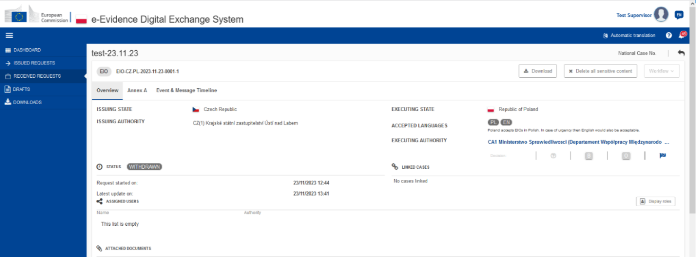
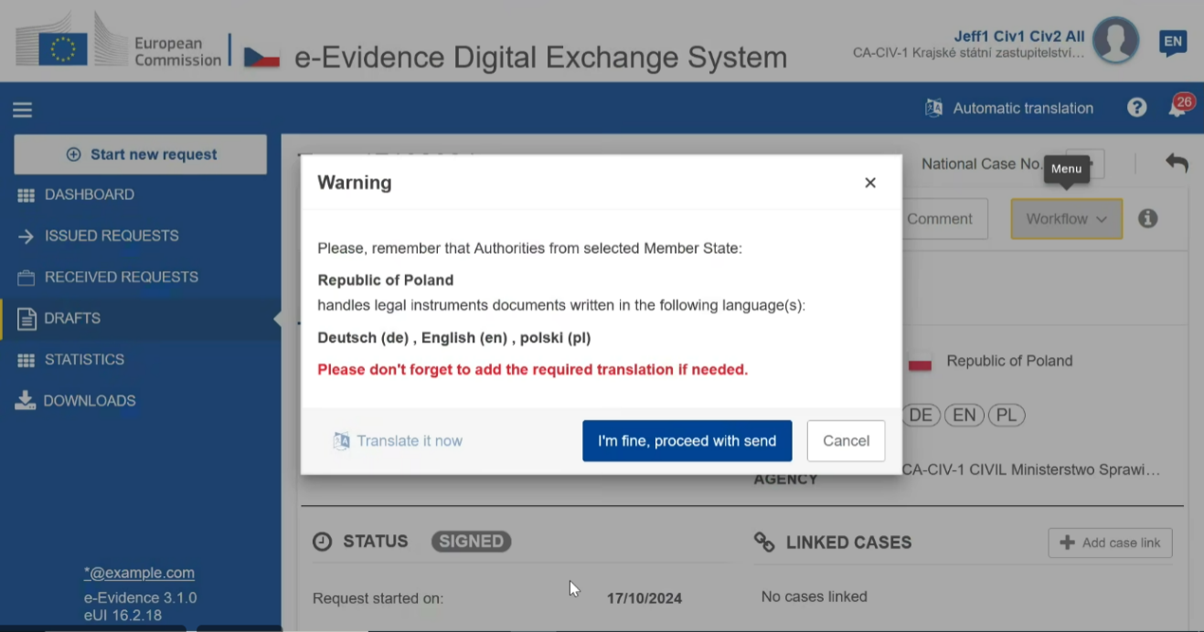
In principle, the translation should be carried out by sworn translator(s) and be attached as a file to the request.
The machine translation tool (eTranslation) () that is integrated into the RI may be used in urgent cases or for preliminary guidance. However, it does not replace the obligation to provide an official translation of the request in one of the accepted languages.
In exceptional cases where the form is completed via the e-Justice Portal, the requesting authority should start by filling in the fields of the relevant form in their language and then at the end select the button that allows the form to be converted into the language accepted by the court or authority addressed. The information entered is not translated automatically and would need to be provided in the language that the requested Member State is able to accept.

What type of signature is needed?
The field at the end of the forms should record the place and date of completion and, importantly, the name and signature and/or stamp of an authorised official of the requesting or requested court.
The court should make sure that the form is always signed or stamped/sealed by one of the following means:
- qualified electronic signature;
- qualified electronic seal;
- handwritten signature;
- stamp.
If you are using the decentralised IT system, electronic methods should be preferred as the system cannot verify handwritten signatures or stamps.
In the RI, you can select one of the following options for signatures:
- Signature in PAdES format () (default and recommended option);
- Other types of signatures.
If you select ‘Other types of signatures’, you can then upload another type of document (e.g. jpg, jpeg, png). The document must be signed with one of the following: digital signatures or seals, stamps, handwritten signatures. When drafting the guidance within the RI, the documents need to be signed outside of the RI and uploaded afterwards.

General fields in most forms
You do not need to enter the contact details of the requesting and requested authorities (Sections 3. and 4.) and the reference numbers (Sections 1. and 2.) manually when working with the RI. The system will gather the data from the other forms that have already been exchanged. The situation might be different when using a national IT solution. When filling in the forms, special attention should be paid to entering the reference number of the requesting court (Section 1.) as well as that of the requested authority (Section 2.) to ensure that the form can be assigned to a pending case.
Section 1: The requesting court should enter its file number or any other relevant reference in order to facilitate communication between the relevant authorities and enable smooth communication and correct assignment.
Section 2: The requested authority (requested court, central body or competent authority) should enter its file number or any other relevant reference in order to facilitate communication between the relevant authorities and enable smooth communication and correct assignment.
Section 3: The official name and contact details of the requesting court should be entered here. To assist the court in the requested Member State, it might be helpful to provide in brackets a translation of the name and type of court (e.g. whether it is a court of first instance or appeal). When sending the request electronically and using the RI, the official name and contact details of the requesting court are prefilled as uploaded in the court database (CDB).
Section 4: The contact details of the requested court (requested court, central body or competent authority) should be entered here. When sending the request electronically and using the RI, the fields are filled in automatically with the data of the requested court chosen based on where the evidence to be collected is located. The Regulation provides for direct contact between the requesting and requested court. The request is therefore sent to the requested court in the other Member State without the involvement of another authority in that Member State. The address details of the court that is requested to take evidence have to be filled in here.
If the request is sent by alternative means due to extraordinary circumstances, the competent court in the other Member State as well as its contact details can be found on the e-Justice Portal in the European Judicial Atlas in civil matters (https://e-justice.europa.eu/topics/taking-legal-action/european-judicial-atlas-civil-matters_en ). Choose the section ‘Taking of evidence (recast)’ and then the heading ‘Competent courts/authorities’. Choose the Member State that the request needs to be sent to, select ‘Requested Courts’ and the municipality or postal code where the evidence is located. The competent court and its address will be displayed.

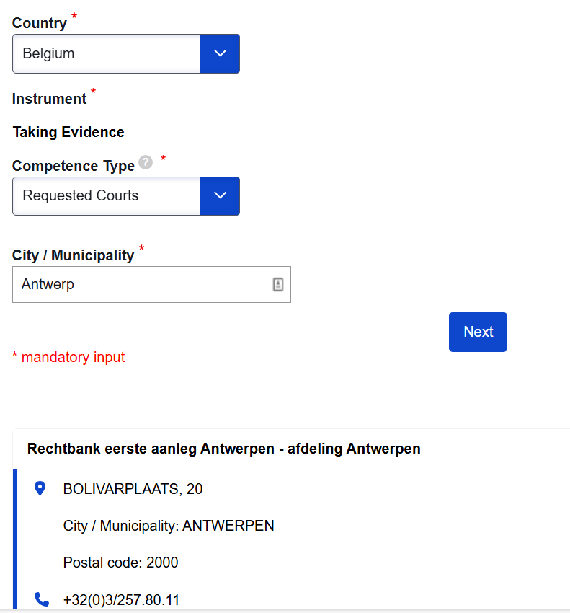
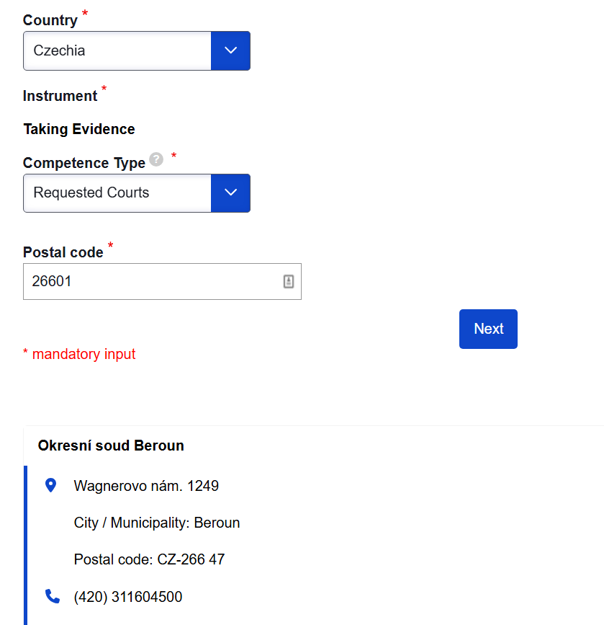
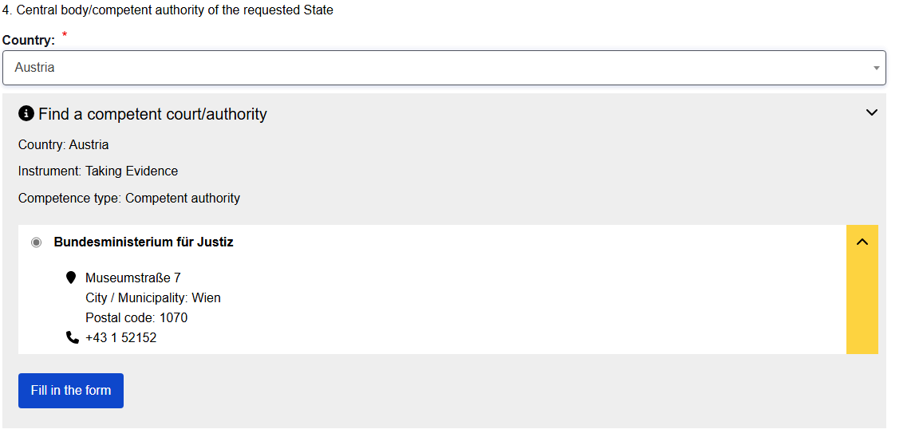

Explanation of the content of forms A – N

Form A

What is this form for?
In accordance with Article 5(2), this form is to be used if the indirect taking of evidence is sought, meaning that the requesting court in Member State A requests the requested court in Member State B to take evidence. Normally evidence in that case is taken according to the law of the requested court in Member State B, if no special procedure has been asked for.
If necessary, attachments may be used. Attachments should be clearly identified and referenced in Form A. If sent by paper, the attachment should be securely fastened to the request.
If the direct taking of evidence (the requesting court wants to take evidence without the involvement of a court in the other Member State) is sought, then Form L needs to be used (see also point 6.12 of this Annex).
Section 1: The requesting court should enter its file number to facilitate communication between the requesting and requested court and enable smooth communication and assignment to the correct case.
Section 2: The address details of the court requesting the taking of evidence must be filled in here. Also add an email address even if the request is being sent via the decentralised IT system. An email address facilitates communication if the IT system is not working. If the request is being sent by alternative means due to exceptional circumstances, an email address facilitates further coordination of the request and might speed up execution.
When sending the request electronically and using the RI, the fields are filled in automatically with the data of the requesting court. The situation might be different when using a national IT solution.
Section 3: The address details of the court that is requested to take evidence have to be filled in here. When sending the request electronically and using the RI, the fields are filled in automatically with the data of the requested court chosen based on where the evidence to be collected is located. The situation might be different when using a national IT solution. The Regulation provides for direct contact between the requesting and requested court. The request is therefore sent to the requested court in the other Member State without the involvement of another authority in that Member State.
If the request is sent by alternative means due to extraordinary circumstances, the competent court in the other Member State as well as its contact details can be found on the e-Justice Portal in the European Judicial Atlas in civil matters ( https://e-justice.europa.eu/topics/taking-legal-action/european-judicial-atlas-civil-matters_en ). Choose the section ‘Taking of evidence (recast)’ and then the heading ‘Competent courts/authorities’. Choose the Member State that the request needs to be sent to, select ‘Requested Courts’ and the city/municipality where the evidence is located. The competent court and its address will be displayed.
Step 1:
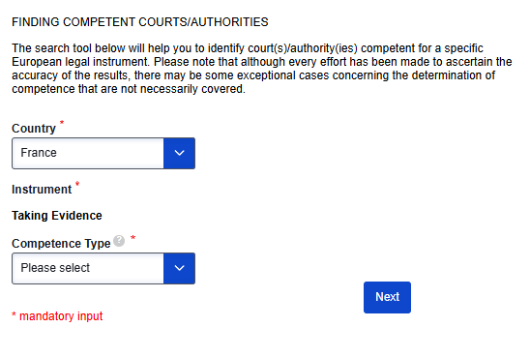

Step 2:
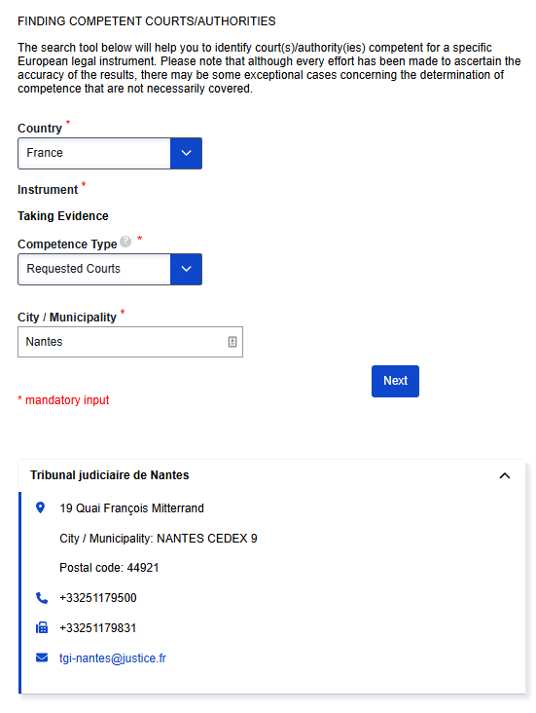
If the form is filled in online on the e-Justice Portal, the dynamic forms help determine the requested court. The address and contact details of the chosen requested court will be filled in automatically:
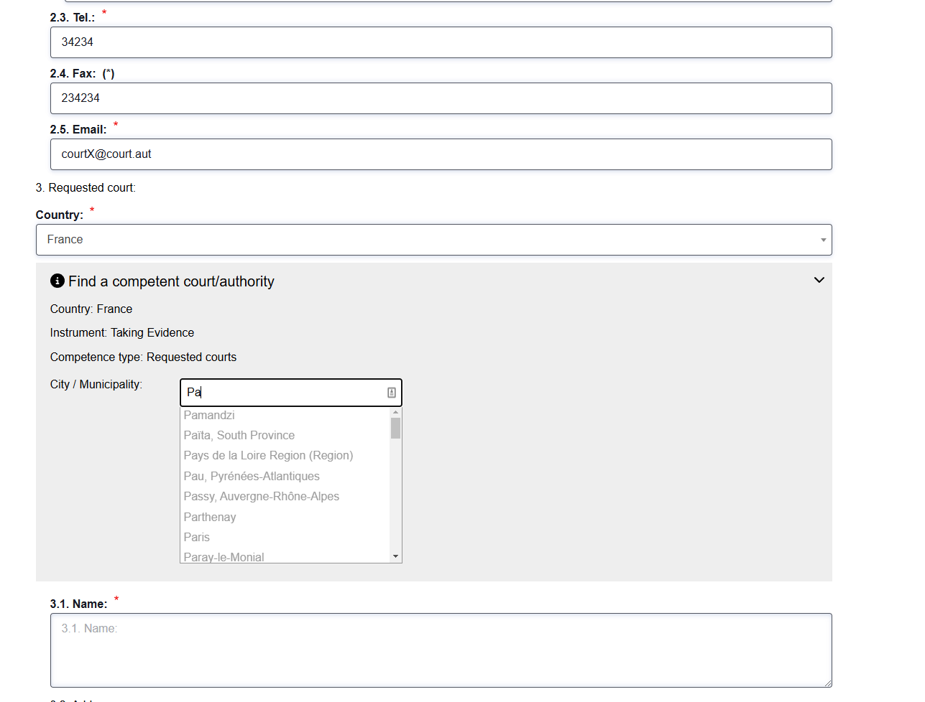
An email address (3.5.) facilitates communication if the decentralised IT system is not working. If the request is being sent on paper due to exceptional circumstances, an email address facilitates further coordination of the request and might speed up execution.
Section 4: You should provide details of the claimant/petitioner here. If you are using the RI, you can add more than one claimant. The situation might be different when using a national IT solution. It is worthwhile adding an email address even if the field is optional. Providing an email address might facilitate further correspondence, in particular if the parties wish to be present.
If the request is sent by alternative means and multiple claimants exist as it is not possible to add all claimants on the e-Justice Portal, only the main claimant should be named in the form followed by ‘and others’.
Section 5: If the claimant/petitioner has appointed a representative, the contact details must be included here. As noted under Section 4, adding an email address might facilitate further correspondence, in particular if the representatives wish to be present.
Section 6: You should provide details of the defendant/respondent here. If you are using the RI, you can add more than one defendant. The situation might be different when using a national IT solution. It is worthwhile adding an email address even if the field is optional. Providing an email address might facilitate further correspondence, in particular if the parties wish to be present.
If the request is sent by alternative means and multiple defendants exist as it is not possible to add all defendants, only the main defendant should be named in the form followed by ‘and others’.
Section 7: If the defendant/respondent has appointed a representative, the contact details must be displayed here. As noted under Section 4, adding an email address might facilitate further correspondence, in particular if the representatives wish to be present.
Section 8: Fill in this section if parties and/or their representatives wish to be present during the execution of the request either in person or by video link (in that case, Form N needs to be completed as well).
Under point 8.1., you need to enter the names of the parties and representatives. It might also be possible not to name the parties and representatives, but to insert only their function as ‘claimant and representative’ (see points 4 and 5) or ‘representative’ (see point 5).
Point 8.2. must be filled in if the parties and representatives named in 8.1. will not only take part in the execution, but also want to actively participate. In the event of participation by video conference or by other distance communication technology, Form N needs to be completed as well. In that case, describe the mode of participation as thoroughly as possible (e.g. ask the witness questions) so that the requested court is able to decide on the conditions of their participation.
If the parties/representatives require interpretation, provide details under point 8.3. If the box ‘other’ is ticked, specify the language needs in the field below.
Section 9: Fill in this section if the requesting court wishes to be present during the execution of the request either in person, by video conference or by other distance communication technology (in that case, Form N needs to be completed as well). Point 9.1. needs to be ticked if the court just wishes to be present. If the court wants to participate actively in the taking of evidence, point 9.2. needs to be ticked and several subpoints need to be filled in. The participating member of the court must be named, together with their title (e.g. judge at the local court) and function (judge, court reporter etc.). Under point 9.2.4., describe the tasks that the member of the court will execute during the taking of evidence (e.g. ask the witness additional questions) in a detailed and comprehensive way.
If the representative of the court requires interpretation, provide details under point 9.3. If the box ‘other’ is ticked, specify the language needs in the field below.
Section 10: Describe the nature of the proceedings in a precise manner and in such a way as to ensure that the foreign court unfamiliar with litigation practices in the requesting state will understand the request. The amount of information provided depends on the proceedings and the evidence being sought. The information given should allow the requested court to check whether the request falls within the scope of the Regulation, especially whether the matter is of civil or commercial nature. Clearly indicate whether the person to be heard is a witness, an expert or a party.
Section 11:
Point 11.1. should give a short but precise description of the facts on which evidence is being sought. This might be a description of the pleadings of the parties or a summary of the court decision on which evidence is being sought. After reading the information, the requested court should be able to execute the request as precisely as needed for the pending proceedings. Bear in mind that the requested court only has the information given in Form A and the attachments for execution in order to execute the request properly. Points 11.2. to 11.3. specify this point further. Under point 11.2., provide complete and accurate information on the person to be examined as it is crucial for the requested court to readily identify and notify the witness. Where evidence is sought from multiple persons, issue a separate request for each person. Also consider adding an email address as well as phone and fax number to ensure that the witness can be contacted easily and without delay. If a witness is to be questioned, the questions to be put to them should be listed under point 11.2.7. Questions should be drafted in a clear and precise manner to enable the requesting court to execute the request as being asked for by the requesting court. If questions are less precise or vague, the results of the witness examination might not be useful for the pending proceedings. Questions may be specified in an attachment, especially if the request is sent by alternative means and is not being sent through the decentralised IT system.
If the witness decides to invoke the privilege or duty to refuse to give evidence under the law of the requesting state, this information should be given under point 11.2.8. It is advisable to specify this right under point 11.2.10. by stating the national provisions applicable in that case and their wording, and to ask the requested court to instruct the witness accordingly. Where needed, you can attach an extract of the relevant law to Form A.
If the requesting court wishes the evidence to be given on oath or affirmation, you should tick box 11.2.9. If a specific form of oath is required, the exact wording should be stated under point 11.2.10. You can also add any other information that is regarded as necessary, for example that the requested court needs to instruct the person to be heard. In some jurisdictions, the right to refuse to testify can also include the right to refuse to testify under oath. You should also mention this information and the request to instruct the witness accordingly.
Fill in point 11.3. if other taking of evidence is being sought (e.g. a document is to be inspected, an expert report is requested).
Section 12:
If box 12.1. or 12.2 is not ticked, the requested court will execute the request applying its own national procedural law. However, according to Article 12(3) of the Regulation it is possible to ask the requested court to execute the request in accordance with a special procedure (12.1.) to ensure that the evidence is obtained in a form that can be used in the pending proceedings at the requesting court, or by the use of communication technology (12.2.) such as video link or telephone. If box 12.2. is ticked, you must attach Form N to Form A in all cases. Examples for a specific method can be the production of a verbatim script, recording of the hearing or cross-examination. You should describe the method requested as precisely as possible in order to allow the requested court to follow this method. It might be useful to attach the relevant national legislation or to state it under point 12.3. The requested court will execute the request accordingly if the requested procedure is compatible with its national law or it is unable to do so because of major practical difficulties.
Section 13:
A request for the taking of evidence should be transmitted via the decentralised IT system electronically. However, according to Article 7(4) of the Regulation it is possible in specific cases to send requests by alternative means (such as secure email or paper). Section 13 gives examples for such exceptional circumstances that allow a request to be sent by postal services. For example, exceptional circumstances might be that a DNA testing kit has to be sent to the requested court.

Form B

What is this form for?
This form is used by the requested court to acknowledge the receipt of a request transmitted by the requesting court. The requested court should send it within seven days of receiving the application (Article 9(1)), and the RI will automatically remind it of that time limit. Sending Form B within seven days is sufficient to meet the deadline. If the request does not meet the requirements of Articles 6 and 7, the requested court should make a note of this in the form.
Section 5: The requested court should record the date of receipt here.
Section 6: Where the requested court refuses to process the application because it believes that the request does not comply with the required conditions of the Regulation (Article 6 or 7), it should set out the reasons here.
Point 6.1: This applies if the request for taking evidence is not made in the official language of the Member State where the evidence is being requested or in another language that the Member State has agreed to accept. If the Member State has multiple official languages, the request can be made in the official language of the specific place where the evidence is to be taken.
Point 6.1.1: The requested court that refuses to process the application should indicate which language should be used to complete the request.
Point 6.2: This applies if the requested court deems the request illegible (for example due to the poor quality of scanned documents) and they are therefore unable to identify whether they are competent or not or are unable to understand the request itself. Illegibility must therefore be reported to the requesting court.

Form C

What is this form for?
This form should be filled in by the requested court if it is not competent to execute the request. Nevertheless, the requested court has to forward the case to the competent court within their Member State and inform the requesting court by means of Form C in accordance with Article 9(2).
Section 4: The requested court should provide the details of the court competent to execute the request by indicating the name and address of the competent court under points 4.1.-4.5. The details are prefilled in the RI. Check that an email address is displayed even if the request is sent via the decentralised IT system. An email address facilitates communication if the IT system is not working. If, due to exceptional circumstances, the request is sent by other means, an email address will facilitate further coordination of the request and may speed up its execution.

Form D

What is this form for?
This form should be used by the requested court if the request received does not contain all the information needed to execute the request. Form D does not apply if an inadmissible language is used (Article 6) or when the request is illegible, because these shortcomings must already be pointed out in the acknowledgment of receipt – Form B. Form D may only be used if the requested court is unable to comply with the request due to missing information.
Section 5: The requested court should indicate any missing information necessary to execute the request within 30 days of receiving it in accordance with Article 10. It should specify the deficiencies precisely.
Section 6: Where the opinion of an expert is required, the requested court may request an adequate deposit or advance towards the anticipated costs of the expert opinion. All the information needed to make the payment should be included in the following subpoints:
- in point 6.1, special attention should be paid to the correctness of the account owner;
- in point 6.3, the bank name/BIC or other relevant bank code (e.g. SWIFT) and the account number/IBAN provided;
- in point 6.7, the reference number of the payment/description/message to the recipient;
- indicate the amount of the deposit or advance in point 6.5 and the relevant currency in point 6.6;
- where relevant, indicate the date by which the payment should be made in point 6.4.

Form E

What is this form for?
This form is a follow-up to Form D and is used to acknowledge receipt of the requested deposit or payment.
Section 5: The requested court should record the date of receipt of the deposit or advance here in accordance with Article 10(2).

Form F

What is this form for?
This form can be used by the requesting court as a reminder when no information has been received on the outcome of the request. It is recommended that the requesting court first uses this form to find out the state of execution of the request or what is preventing its successful execution. If there is no reply or if the reply is not satisfactory, the court may ask the central body for assistance.
According to Article 12(1), the requested court, central body or competent authority shall execute the request without delay and, at the latest, within 90 days of receipt of the request.
Section 5:
The requesting court may attach the original request (Form A or Form L) where deemed necessary.
The relevant boxes should be checked to indicate which documents are already available for the requesting court.
Point 5.1: The requesting court should indicate the date it sent the original request to the requested court, central body or competent authority.
Point 5.2: This box should be checked if the requesting court already received Form B from the requested court, central body or competent authority. It should indicate the date when it received Form B here.
Point 5.3: This box should be checked if the requesting court already received Form J from the requested court, central body or competent authority. It should indicate the date when it received Form J here.
Point 5.4: This is a free text field where the requesting court should indicate all other documents or information received from the requested court.

Form G

What is this form for?
Form G should be used to reply to an inquiry sent by means of Form F. The requested court, central body or competent authority should explain why there has been a delay or what is hindering the successful execution of the request.
Section 5: The relevant boxes should be checked to indicate the reason for the delay.
Point 5.1: This box should be ticked if the requested court, central body or competent authority did not receive the request for taking of evidence either via Form A (request for the indirect taking of evidence, Articles 5 and 12) or Form L (request for the direct taking of evidence, Article 19).
Point 5.2: This box should be ticked if the process of finding the current address of the person who is supposed to be examined is still ongoing. In other words, efforts are being made to locate where the person lives or can be contacted, and this process has not yet been completed.
Point 5.3: This box should be ticked if the process of delivering a summons (a formal notice) to the person who is to be examined requires them to appear in court for the purposes of the taking of evidence.
Point 5.4: This box should be checked if the person to be examined (e.g. witness or expert) missed the hearing even though they were served with the summons.
Point 5.5: This box should be checked if the request has already been dealt with. The sent response should then be resent.
Point 5.6: This box should be checked if the requested court, central body or competent authority has not received the requested advance payment or deposit from the requesting court.
Point 5.7: This box should be checked if there are other reasons for the delay. These should be described in detail in the free text field.
Section 6: The requested court, central body or competent authority should specify when the request is expected to be carried out. A precise date should be provided.

Form H

What is this form for?
The requested court should use this form in accordance with Articles 12(3) and 12(4) of the Regulation if the requested special procedure cannot be complied with. This form is therefore an answer to Form A. The requested court can only reject the use of the special procedure if this procedure is incompatible with the law of the requested court or its adherence is impossible due to major practical difficulties. In such situations, the requested court must still process the request according to its national law, in accordance with Article 12(2) of the Regulation. It is advisable to ask the requesting court, along with the submission of Form H, whether it wishes the evidence to be taken without the requested special procedure, i.e. under the national law of the requested court in accordance with Article 12(2).
This is not a rejection of the request within the meaning of Article 16. Form K should be used for that.
Section 5: The requested court has to indicate the reasons for the rejection of the taking of evidence using the special procedure. The grounds for refusal stated in Article 12(3) are to be interpreted autonomously, conclusively and narrowly.
Point 5.1: This box has to be ticked if the national law of the requested court does not allow the requested procedure for the taking of evidence for example to protect the witness against the use of compulsory measures. It is not sufficient to reject the request simply because the domestic procedural law does not recognise the requested special procedure. The reasons for rejection must be of a fundamental nature.
Point 5.2:
This box has to be ticked if it is impossible for the requested court to take evidence by using the special procedure.
Section 6:
Point 6.1: This box has to be ticked if the national law of the requested court does not allow the use of the requested communication technology for the taking of evidence. It is not sufficient to reject the request simply because the domestic procedural law does not recognise the procedure for the requested evidence gathering. The reasons for rejection must be of a fundamental nature.
Point 6.2: This box has to be ticked if it is impossible for the requested court to take evidence by using the requested communication technology, for example if such technology is not available in the requested court.

Form I

What is this form for?
This form should be filled in by the requested court. If the requesting court has asked for the participation of parties, representatives or for its own participation, the requested court might impose conditions on this participation. If it is only envisaged to be present when the request is executed, the court and/or the parties and representatives need to be informed about the time and place of the taking of evidence. In that case, the requested court needs to send Form I after having confirmed the receipt of the request with Form B. The decentralised IT system does not allow to send multiple forms all at once (i.e. Form H and Form I). Forms need to be sent one after another.
Section 5
The requesting court is informed about the date and time of the taking of evidence. Information in Form A on the preferred date and time should be taken into account as well as possible time differences between the location of the requesting court and the requested court. It is therefore advisable to communicate which time zone you are referring to (CET for Central European Time, WET for West European Time and EET for Eastern European Time).
Section 6
This section needs to be completed if the taking of evidence is not taking place in the premises of the requested court but in some other place. If the witness is being heard using videoconferencing technology, you should also add this information and provide details on how to connect to the videoconference.
Sections 7 and 8
If participation of the parties, representative or the requesting court is requested, the requested court may impose conditions on this participation. Any condition imposed should be added in Section 7. Conditions might be that no cross-examination is to take place or that participating parties need to understand the language of the hearing.

Form J

What is this form for?
Form J must be used by the requested court pursuant to Article 17 if there have been delays in the execution of the taking of evidence. The requested court must provide specific reasons for the delay; generic references to workload are not sufficient. It should only be used with requests for the indirect taking of evidence.
Section 5:
Point 5.1: This box should be ticked if the process of finding the current address of the person who is supposed to be examined is still ongoing. In other words, efforts are being made to locate where the person lives or can be contacted, and this process has not yet been completed.
Point 5.2: This box should be ticked if the process of delivering a summons (a formal notice) to the person who is to be examined requires them to appear in court for the purposes of the taking of evidence.
Point 5.3: This box should be checked if the person to be examined (e.g. witness or expert) missed the hearing even though they were served with the summons.
Point 5.4: This box should be checked if the request has already been dealt with. The sent response should then be resent.
Point 5.5: This box should be checked if the requested court has not received the requested advance payment or deposit from the requesting court.
Point 5.6: This box should be checked if there are other reasons for the delay. These should be described in detail in the free text field.
Point 6: The requested court should specify when the request is expected to be carried out. A precise date should be provided.

Form K

What is this form for?
Form K informs the requesting court about the execution or non-execution of the request and states the reasons. It is filled in by the requested court.
Section 5
This section should be filled in if the request has been executed successfully. Normally it is not necessary to state any details in the form itself, but the documents that were drawn up when executing the request should be listed (i.e. written statement of the witness, see attachment 1; protocol of the hearing, see attachment 2). The documents themselves are then attached to Form K. The documents attached to the form do not need to be translated into the language of the requesting court. It is the task of the requesting court to obtain a translation. Documents that have been drawn up to summon the person to be heard, information on rescheduling the date of the hearing or internal court documents do not need to be attached.
Section 6
If it was not possible to execute the request, Section 6 needs to be completed instead of Section 5. In addition, either 6.1., 6.2., 6.3., 6.4. or 6.5. needs to be completed.
If the witness invoked the right to refuse to give evidence or claimed to be prohibited from giving evidence, box 6.1. should be ticked followed by box 6.1.1. if the witness referred to the law of the requested court. Box 6.1.2. should be ticked if the witness referred to the law of the requesting court.
When executing the request, the requested court will check whether the request falls within the scope of the Regulation, i.e. whether the request is civil or commercial in nature and that the request is for the taking of evidence. In doing so, the court will take an autonomous approach, taking into account the rulings of the Court of Justice of the European Union (CJEU). For further details, see Chapter 3 of this Guide. If this is not the case, box 6.2. should be ticked.
Box 6.3. needs to be ticked if the requested action is not a task of the judiciary in the requested state. This might be the case when an address is sought, but also if a witness enjoys immunity under the Vienna Convention. For further details, see Chapter 7.4.2 of this Guide.
If Form D was sent to the requesting court asking for additional information and it failed to provide the requested court with the additional information, the requested court can reject the request and should do so by ticking boxes 6.4. or 6.5. The first box concerns the case where additional information has been asked for and the requesting court failed to answer within 30 days (postal delivery time should be taken into account). An example would be that the requested court was unable to locate the witness and asked the requesting court to provide a new address. Box 6.5. concerns the case where a deposit has been asked for and it has not been made by the requesting court within the time limit of 60 days. As mentioned above, the postal delivery time should be taken into account. Such a deposit can only be asked for an expert report (Article 22(3)). Box 6.5. can therefore only be ticked if an expert report has been requested and the deposit was not made.
Section 7
Point 7 should be ticked if the request is rejected for reasons that are not stated in point 6 above, e.g. the witness to be heard is deceased.

Form L

What is this form for?
In accordance with Article 19, this form is to be used for the direct taking of evidence. This means that the court of Member State A may, in accordance with its national law, take evidence directly in Member State B. Such a request for the direct taking of evidence must be accepted by Member State B under the conditions determined by the central body or competent authority of the requested Member State.
The court requesting the direct taking of evidence in another Member State should send its request to the central body or competent authority designated by the Member State.
If necessary, annexes may be used for the summary of the case or for a brief description of the subject matter and the methods used for the taking of evidence. Attachments should be clearly identified and referenced in the form. If sent on paper, the annexes should be securely attached to the request.
Section 1: The requesting court should indicate its case number in order to allow for smooth communication and allocation to the correct case.
Section 2: The reference number of the central body/ competent authority may be added if known.
Section 3: Enter the address of the court requesting the direct taking of evidence. The section is prefilled in the RI. Checked that an email address is displayed even if the request is sent via the decentralised IT system. An email address facilitates communication if the IT system is not working. If the request is sent by other means due to exceptional circumstances, an email address will facilitate further coordination of the request and may speed up execution.
Section 4: The request for the direct taking of evidence should be sent to the central body/ competent authority of the requested Member State for approval. The address details of the central body/ competent authority to which the request for the taking of evidence is addressed must be filled in here. If the request is sent electronically and the RI is used, the fields will be filled in automatically with the data of the central body/ competent authority. The situation may be different when using a national IT solution.
If the request is sent by alternative means due to extraordinary circumstances, the central body/ competent authority in the other Member State as well as its contact details can be found on the e-Justice Portal in the European Judicial Atlas in civil matters (https://e-justice.europa.eu/topics/taking-legal-action/european-judicial-atlas-civil-matters_en). Select the section ‘Taking of evidence (recast)’ and then the heading ‘Competent courts/authorities’. Select the Member State that the request should be sent to and then select ‘Central Body’. The central body and its address will be displayed.
If the form is filled in online on the e-Justice Portal, the dynamic forms will help to identify the ‘Central body/competent authority’. The address and contact details of the central body/competent authority will be filled in automatically:
An email address (4.5.) facilitates communication if the IT system is not working. If, due to exceptional circumstances, the request is sent by other means, an email address will facilitate further coordination of the request and may speed up execution.
Section 5: Details of the claimant/petitioner(s) must be provided in this section. It is possible to add more than one claimant if the RI is used or the forms are filled in using the e-Justice Portal. The situation may be different if a national IT solution is used. The inclusion of an email address should be considered, even if it is optional. Providing an email address may facilitate further correspondence, in particular if the parties wish to be present when the request is executed.
Section 6: If the claimant/petitioner has appointed a representative, their contact details must be provided here. As noted in Section 5, the inclusion of an email address may facilitate further correspondence, particularly if the representatives wish to be present when the request is executed.
Section 7: Details of the defendant/respondent must be provided in this section. It is possible to add more than one defendant if the RI is used or the forms are filled in using the e-Justice portal. The situation may be different if a national IT solution is used. The inclusion of an email address should be considered, even if it is optional. Providing an email address may facilitate further correspondence, in particular if the parties wish to be present when the request is executed.
Section 8: If the defendant/respondent has appointed a representative, their contact details must be provided here. As noted in Section 5, the inclusion of an email address may facilitate further correspondence, particularly if the representatives wish to be present when the request is executed.
Section 9: The requesting court must designate and provide the person or persons to obtain the evidence. The details of the designated person or persons must be provided in this section together with the requested task (9.4.). Person(s) and tasks may vary depending on the type of evidence.
Section 10: This section should provide a brief summary of the case and the basic facts for seeking evidence. This might be a description of the pleadings of the parties or a summary of the court decision. Remember that this is the only information that the central body or competent authority will have about the case, so the information should be as accurate as possible. It is important to note that any information provided will allow the central body/competent authority to assess whether the request falls within the scope of the Regulation, in particular whether the matter is of a civil or commercial nature.
If, due to exceptional circumstances, the request is sent by alternative means, the above information may be given in the Annex. In that case, it is advisable to introduce a new case in the decentralised IT system and give details there. It is important to indicate in the system that a paper request will follow. In this case, the paper request must refer to the request already sent through the system.
Section 11: The nature of the evidence to be obtained should be described clearly and precisely, in a manner that ensures a foreign court (if involved) or central body/competent authority – unfamiliar with the litigation practices of the requesting state – can fully understand the request (11.1.). The level of detail provided will depend on the specific proceedings and the type of evidence being sought (i.e. hearing of the witness, expert or parties).
When hearing a witness, all contact details need to be added under point 11.2. The contact details should be as detailed as possible to make it easier to identify the person. Where evidence is sought from multiple persons, a separate request for each person needs to be issued. The inclusion of an email address should be considered, even if it is optional. Providing an email address may facilitate further contact with the witness when the request is executed. The same applies to the telephone number, especially if the requesting court is prepared to hear the witness by phone.
The court should also provide details of any questions or facts that the requesting court intends to put to the witness during the hearing (11.2.7.). If the drafted questions are imprecise or vague, the results of the witness examination might not be useful for the pending proceedings. If the witness decides to invoke the privilege or duty to refuse to give evidence under the law of the requesting state, this information should be given under point 11.2.8. It is advisable to specify this in an annex by stating the national provisions applicable in that case and their wording.
If the requesting court also wishes to take another type of evidence, this should be noted and described in detail under point 11.3.
If, due to exceptional circumstances, the request is sent by alternative means, the information under points 11.1., 11.2.7. and 11.3. may be given in the Annex. In that case, it would also be possible to start a new case in the decentralised IT system and give details there. It is important to indicate in the system that a paper request will follow. In this case, the paper request must refer to the request already sent through the system.
Section 12: Form N should be sent together with Form L and/or Form M if the court wishes to take evidence by videoconference or other distance communication technology. In the RI, Form L and/or Form M should be sent first, followed by Form N.

Form M

What is this form for?
The central body or competent authority of the requested Member State must use this form to give its consent to the request for the direct taking of evidence. It should inform the requesting court within 30 days whether and under what conditions the request is accepted.
Section 1: In order to facilitate smooth communication between the requesting court and the central body/ competent authority, the latter should indicate the case number of the requesting court previously indicated in Form L.
Section 2: The reference number of the central body/ competent authority must be filled in.
Section 3: Enter the name of the court requesting the direct taking of evidence.
Section 4: Enter the name and address details of the central body/ competent authority that is responsible for approval of the request for the direct taking of evidence.
If the request is sent electronically and the RI is used, the fields will be filled in automatically with the data of the central body/ competent authority. The situation may be different when using a national IT solution.
Section 5: Within 30 days of receiving the request, the central body or competent authority must inform the requesting court whether its request for the direct taking of evidence has been accepted (5.1.).
If necessary, the central body or competent authority may also determine under which conditions the request is to be carried out in accordance with its law (5.2).
If it concludes, on the basis of the information provided by the requesting court, that the request for the direct taking of evidence is not admissible, the request must be refused (5.3.). In this case, the central body or competent authority must tick the reason why the request was refused: (i) the request is not within the scope of the Taking of Evidence Regulation (5.3.1.); (ii) the contact details or the content of the request were not sufficient (5.3.2.); (iii) the type of evidence sought is inadmissible because it is not in accordance with the fundamental principles of national law (5.3.3.).
Section 6: The central body or competent authority may designate a court in its Member State to participate in the direct taking of evidence. The designated court should be the contact court for further communication. The court should assist the requesting court in the direct taking of evidence and ensure that all conditions are met.

Form N

What is this form for?
If the direct taking of evidence is carried out by videoconference or using other distance communications technology, communication between the requested court and requesting court is a key factor in all stages of the process. To ensure a successful connection between the requesting and requested court, the requesting court must use this form to send practical and technical information for holding a videoconference to the requested court, central body or competent authority of the requested Member State or the court assigned.
Section 1: The reference number of the requesting court may be entered. This information is essential if the form is not sent directly with Form L. With the decentralised IT system, the data is filled in automatically as the system collects the data from the other forms that have already been exchanged; the situation may be different if a national IT solution is used.
Section 2: The reference number of the requested court may be filled in. With the decentralised IT system, the data is filled in automatically as the system collects the data from the other forms already exchanged; the situation may be different if a national IT solution is used.
Section 3: The name of the court requesting the direct taking of evidence may be filled in. This information is essential if the form is not sent directly with Form L. With the decentralised IT system, the data is filled in automatically as the system collects the data from the other forms already exchanged; the situation may be different if a national IT solution is used.
Section 4: The name of the requested court responsible for assisting in the execution of the request for the direct taking of evidence may be entered. With the decentralised IT system, the data is filled in automatically as the system collects the data from the other forms already exchanged; the situation may be different if a national IT solution is used.
Section 5: The requesting court should provide the requested court with the technical details to enable the connection between the courts. It is important to provide the data for setting up the videoconference (ISDN, IP), the telephone number of the courtroom for communication or any other relevant information, such as the technical capabilities of other equipment.
Section 6: If more options for communication are mentioned in Section 5, it is useful to indicate the preferred form of connection.
Section 7: Suggested dates and times for the connection should be included. It is useful to propose more possible dates and times to find the most convenient date for the hearing.
The concrete dates can be agreed through the decentralised IT system or through informal communication (e.g. email, phone call).
Section 8: Proposals for dates and times for the test connection to verify interoperability and the proper functioning of the equipment should be entered in points 8.1. and 8.2. It is useful to propose more possible dates and times to find the most convenient date for the hearing.
The concrete dates can be agreed through the decentralised IT system or through informal communication (e.g. email, phone call).
Under point 8.3., it is important to indicate the person responsible for technical assistance during the test call and the connection.
In point 8.4. the language of communication between the requesting and requested court should be ticked. If the box ‘other’ is ticked, specify the language needs in the field below.
In the event of technical difficulties with the videoconference connection during testing, it is advisable to also enter a telephone number in point 8.5.
Section 9: The requesting court should inform the requested court whether it needs assistance in finding an interpreter and, if so, between which languages. This applies if the requesting court does not provide the interpreter itself. If the box ‘other’ is ticked, specify the language needs in the field below.
Section 10: The requesting court should tick the box if the videoconference will be recorded. This will also depend on technical and legal possibilities.
Section 11: There might be other important/practical information or clarifications that the requesting court has asked the requested court for, such as organisational assistance, information on the booking system, requirements for taking oaths, how to start, manage and end the videoconference, or the hostname of the virtual room.

Annex VI: Reference questions and answers

Practical information

- Where can a requesting court find helpful information on each Member State, especially on requested courts, central bodies, languages accepted for completion of the forms, means accepted for the transmission of the request and other communications, and the central body or competent authority responsible for decisions on requests for the direct taking of evidence?
On the e-Justice Portal, each Member State provided in its notification to the Regulation information on these questions, translated into the languages of each Member State: https://e-justice.europa.eu/321/EN/european_judicial_atlas_in_civil_matters.

- Do the same articles of the Regulation apply to the indirect and direct taking of evidence?
Articles 12 to 18 only apply to the indirect taking of evidence. Articles 19 to 21 only apply to the direct taking of evidence. For further information, see Chapter 6 of this Guide.

- What is the difference between a request for the indirect taking of evidence and direct taking of evidence?
The two methods can be distinguished with regard to which court has the primary responsibility over the taking of the evidence procedure:

- Indirect taking of evidence
The responsibility for organising the hearing (summoning the witness, interpreters etc.) lies with the court of the requested Member State, which conducts the taking of evidence in accordance with the request and subsequently informs the requesting court of the outcome. The evidence is taken in accordance with the national law of the requested court. Compulsory measures are possible. The requesting court can nevertheless participate in the hearing (Article 14). This might even mean that the court could ask questions to a witness in a hearing if compatible with the law of the requested court.

- Direct taking of evidence
The requesting Member State remains in charge of the taking of evidence and conducts the actual taking of evidence itself. The evidence is taken in accordance with the national law of the requesting court. Compulsory measures are not possible. The responsibility for organising the hearing (summoning the witness, interpreters etc.) lies with the court of the requesting Member State. However, the requested Member State may assign a court to provide practical assistance (e.g. during videoconferencing).

In both cases, evidence can be taken through local and distant means (such as through a videoconference). For further information, see Chapters 6, 7 and 8 of this Guide.

- How long does it take to execute a request for the taking of evidence?

- Indirect taking of evidence
The requested court must execute the request without delay, at the latest within 90 days of receipt of the request (Article 12(1)). For further information, see Chapter 7.3.1 of this Guide.

- Direct taking of evidence
Within 30 days of receiving the request for the direct taking of evidence, the central body or the competent authority of the requested Member State must inform the requesting court as to whether the request has been accepted (Article 19(4)). For further information, see Chapter 8.1.1 of this Guide.

- Which forms () should I use for a request for the indirect taking of evidence and a request for the direct taking of evidence?
In general, use Form A for a request for the indirect taking of evidence (Article 5(1)). Use Form L in Annex I for a request for the direct taking of evidence (Article 19(1)). Enclose Form N if the indirect or direct taking of evidence is requested by using videoconferencing or another distance communications technology.

- Which form () should I use for the execution/acceptance or refusal of a request for the taking of evidence by the requested court?

- Indirect taking of evidence
Use Form K for the execution (Article 18) or refusal (Article 16(4)) of a request for the indirect taking of evidence. For further information, see Chapters 7.4 and 7.6 of this Guide.

- Direct taking of evidence
Use Form M for the acceptance or refusal of a request for the direct taking of evidence (Article 19(4)). For further information, see Chapter 8.1.1 of this Guide.

- When should I use Form F? What about Form G?
The Regulation sets time limits for the execution of the request (Article 12(1)) or for accepting a request for the direct taking of evidence (Article 19(4)). If the requesting court does not receive information about the stage of proceeding or is not informed about the execution/acceptance of the request within the time limits, the requesting court can use Form F to send a request for information on the delay. The requested court (Article 12(1)) or competent authority (Article 19(4)) should use Form G to reply to the request.

- Concerning urgent requests, are there any ways to speed up the execution of these requests?
The central bodies can help here. The contact points of the European Judicial Network in civil and commercial matters (EJN-civil) also offer assistance in urgent cases to speed up the execution of such requests if assistance via the central bodies is not successful. You can access the contact details of the national contact points via a search tool on the e-Justice Portal: https://e-justice.europa.eu/437/EN/assistance_to_judges_amp_other_judicial_authorities?init=true#tocHeader1.
For further information, see Chapter 10 of this Guide.

- Are there any special rules on videoconferencing or teleconferencing?

- Indirect taking of evidence
The requesting court may ask the requested court to use specific communications technology when executing the request, in particular videoconferencing or teleconferencing (Article 12(4)). The requested court should use the communications technology unless doing so would be incompatible with its national law or the requested court is unable to do so because of major practical difficulties (Article 12(4)). The requesting court should use Form N. For further information, see Chapters 7.3.5 and 9 of this Guide.

- Direct taking of evidence
Where evidence is to be taken by examining a person who is present in another Member State and the court requests the taking of evidence directly in accordance with Article 19, that court should take evidence using videoconferencing or another distance communications technology provided that such technology is available to the court and the court considers the use of such technology to be appropriate in the specific circumstances of the case (Article 20(1)). The requesting court should use Form N. For further information, see Chapters 8.2 and 9 of this Guide.

- Which court has to arrange an interpreter?

- Indirect taking of evidence
For a request for the indirect taking of evidence, the requested court may arrange an interpreter in accordance with its national law (Article 12). In Form A points 8.3 and 9.3, the requesting court may also ask the requested court to provide for interpretation during the hearing. For further information, see Chapter 7.3.4 of this Guide.

- Direct taking of evidence
For a request for the direct taking of evidence that is to be taken by examining a person using videoconferencing or another distance communications technology, the requesting court, upon its request, should be provided with assistance by the requested court in finding an interpreter (Article 20(2)). The requesting court may request such assistance using Form N by marking the tick box under point 9.2. For further information, see Chapters 8.2.3 and 9 of this Guide.

- Which court should reimburse the fees or costs e.g. of an interpreter?
According to Article 22 (1), a request for the taking of evidence should not give rise to any claim for the reimbursement of taxes or costs. This means that for example compensation to witnesses is to be borne by the requested court without the possibility of reimbursement. However, the requesting court should ensure that the fees and costs listed in Article 22(2) are reimbursed without delay, e.g. fees paid for experts and interpreters or costs for the use of videoconferencing requested by the requesting court. If the requesting court requested the direct taking of evidence and an interpreter is appointed by the requesting court directly, the interpreter may request the costs directly from the requesting court. For further information, see Chapters 7.7 and 8.2.3 of this Guide.

- When the requesting court requests the hearing of a witness, does it need to determine a certain day and time for the hearing in the request?

- Indirect taking of evidence
In general, the day and time is determined by the requested court in accordance with its national law (Article 12(2)). The requested court therefore summons the person to be heard and organises the hearing in general. If the requesting court wishes to participate in the hearing, the requested court will use Form N to inform the requesting court about the time and date of the hearing. The representatives of the court do not need to travel to the requested court, they can also participate using videoconferencing facilities. For further information, see Chapter 7.3.2 of this Guide.

- Direct taking of evidence
If the requesting court wants to hear a person directly and without the involvement of a court at the place of residence of the witness, it is up to that court to arrange for the meeting to take place. This includes summoning the person to be heard and determining the time and place of the hearing. If practical assistance of the requested court is asked for, e.g. if the facilities of the requested court are to be used or the person needs to be formally identified, the courts should use Form N point 7 to coordinate the date of the hearing in advance in order to ensure the availability of the court room. This might be the case in particular if the hearing takes place using videoconferencing technology. For further information, see Chapter 8.2.3 of this Guide.

- Is it possible to summon a witness to be heard with coercive measures, such as the threat of a fine?

- Indirect taking of evidence
Where necessary, in executing a request the requested court should apply the appropriate coercive measures to the extent provided for by the law of its Member State (Article 15). For further information, see Chapter 7.3.3 of this Guide.

- Direct taking of evidence
The direct taking of evidence may only take place if it can be carried out on a voluntary basis without the use of coercive measures. Where the direct taking of evidence implies that a person has to be examined, the requesting court should inform that person that the taking of evidence should take place on a voluntary basis (Article 19(2)). For further information, see Chapters 8.1.2, 8.2.3 and 8.3 of this Guide.

- How does the requesting court ensure confidentiality, especially if the requested court orders the documents produced in response to a request for the taking of evidence to be confidential?
The procedures for taking, preserving and presenting evidence should ensure that procedural rights as well as privacy and the integrity and confidentiality of personal data are protected in accordance with EU and national law (Recital 31). The protection of information transmitted is governed by Article 30. As of May 2025, documents will be exchanged through the decentralised IT system that is based on the e-CODEX system. This ensures secure transmission between the courts of different Member States.

Special questions on the indirect taking of evidence

- Can a judge from the requesting court be present and ask questions? Will interpretation be arranged?
Only when compatible with the law of the Member State of the requesting court, representatives of this court may have the right to be present in the taking of evidence by the requested court (Article 14(1)). In the request, the requesting court should use Form A to inform the requested court that its representatives will be present and, where appropriate, that their participation in the taking of evidence is requested. This information may also be given at any other appropriate time (Article 14(3) o). The requested court must determine in accordance with its national law under which conditions the representatives of the requesting court may participate (Article 14(4)). The requesting court may request interpretation into another language if a representative of the requesting court will be present at the taking of evidence (Form A point 9.3.). For further information, see Chapter 7.3.4 of this Guide.

Special questions on the direct taking of evidence

- Is an interpreter needed in cases where the language of the person to be heard is also the language of the requesting state, for example for the judge in the requested state to be able to ensure a due process and legal safety? If so, who is responsible for organising interpretation and who is responsible for the costs of interpretation?
The direct taking of evidence is generally carried out in the language required by the law of the requesting court. Normally this will be the official language of the court’s Member State. If the central body or competent authority assigns a court of its Member State to take part in the direct taking of evidence (Article 19(4)), the central body or competent authority may also inform the requesting court of the condition that the direct taking of evidence is to be carried out in the presence of an interpreter. The requesting court would have to arrange for interpretation in order to meet the conditions set by the requested state. The costs have to be borne by the requesting court. How the costs are divided between the parties to the proceedings is not stipulated in the Regulation, but is governed by the national law of the requesting court. For further information, see Chapters 8.1 and 8.2.3 of this Guide.

- If a person wishes to be heard voluntarily by videoconference and the requesting court allows them to use their own device, and the participation of the court of the Member State in which the person is present is not required by the requesting court, is a request for the direct taking of evidence still required? Is the situation different when the person concerned is a citizen of the Member State of the requesting court?
A request for the direct taking of evidence is required (Articles 19, 20) regardless of the nationality of the citizen to be heard. The fact that the person to be heard is present in the Member State of the requested court is sufficient. A request for the direct taking of evidence should therefore be made (Article 20). The central body or competent authority should inform the requesting court if the request has been accepted and, if necessary, inform the requesting court of the conditions under which the direct taking of evidence is to be carried out according to the law of the Member State of the requested court (Article 19(4)). For further information, see Chapter 8.1.1 of this Guide.

() Regulation (EU) 2020/1784 of the European Parliament and of the Council of 25 November 2020 on the service in the Member States of judicial and extrajudicial documents in civil or commercial matters (service of documents) (recast), OJ L 405, 2.12.2020, pp. 40-78.
() For notifications, see: https://e-justice.europa.eu/321/EN/european_judicial_atlas_in_civil_matters. Choose ‘Taking evidence (recast)’ to see notifications of Member States. For online forms, see: https://webgate.ec.europa.eu/e-justice-online-forms/online-forms/taking-of-evidence-forms_en.
() Further information on the Evidence Convention can be found in the Evidence Section of the website of the Hague Conference on International Private Law: https://www.hcch.net/en/instruments/specialised-sections/evidence.
() Proposal for a Regulation of the European Parliament and of the Council amending Council Regulation (EC) No 1206/2001 of 28 May 2001 on cooperation between the courts of the Member States in the taking of evidence in civil or commercial matters, COM/2018/378 final.
() For the application of the Regulation in the overseas territories of some Member States, consider Article 355 of the Consolidated version of the Treaty on the Functioning of the European Union.
() For more information on the definition of ‘court’, see Chapter 4.
() For more information on the electronic transmission of requests, see Chapter 5.
() For more information on specific communications technology, see Chapter 8.2.
() For more information on Article 21 of the Taking of Evidence Regulation, see Chapter 8.3.
() For further information on the notion of ‘court’, see Chapter 4.
() Consolidated version of the Treaty on the Functioning of the European Union, OJ C 326, 26.10.2012.
() The CJEU has repeatedly stressed that the notion of (civil and commercial matters (should be given an autonomous interpretation. See for example CJEU judgments C-266/01 (ECLI:EU:C:2003:282) and C-103/05 (ECLI:EU:C:2006:471).
() Regulation (EU) No 1215/2012 of the European Parliament and of the Council of 12 December 2012 on jurisdiction and the recognition and enforcement of judgments in civil and commercial matters (recast), OJ L 351, 20.12.2012, pp. 1-32.
() Opinion of the Advocate General in case C-175/06, para 43 (ECLI:EU:C:2007:451).
() Please see also the Taking of Evidence Regulation’s relationship with the Brussels IIb Regulation in Chapter 3.3 of this Guide.
() Depending on the situation, it may be necessary to send a request to the national central authority under Council Framework Decision 2009/315/JHA on the organisation and content of the exchange of information extracted from the criminal record between Member States (ECRIS).
() CJEU, 9 September 2021, in joined cases C-208/20 and C-256/20 Toplofikatsia Sofia and Others, ECLI:EU:C:2021:719. The decision was handed down in relation to Regulation (EC) 1206/2001. The continuity between Regulation (EU) 2020/1784 and the previous instrument (Regulation EC (1206/2001) requires continuity in the interpretation, especially as regards the jurisprudence of the CJEU, i.e. previous case law in this area remains relevant with regard to the Regulation so long as the Regulation does not legislate otherwise.
() Regulation (EU) 2020/1784 of the European Parliament and of the Council of 25 November 2020 on the service in the Member States of judicial and extrajudicial documents in civil or commercial matters (service of documents) (recast), OJ L 405, 2.12.2020, p. 40.
() See information provided by the Member States on the European Judicial Atlas on the e-Justice Portal: https://e-justice.europa.eu/38580/EN/serving_documents_recast?init=true.
() https://e-justice.europa.eu/38581/EN/taking_evidence_recast.
() See Chapter 4 for further guidance in relation to the notion of court.
() See Chapter 3.4 on the non-mandatory nature of the Regulation.
() Council Regulation (EU) 2019/1111 of 25 June 2019 on jurisdiction, the recognition and enforcement of decisions in matrimonial matters and the matters of parental responsibility, and on international child abduction (recast), OJ L 178, 2.7.2019, pp. 1-115.
() Under Article 80(1)(a)(i) of the Brussels IIb Regulation, the central authority of the Member State where the child is or was habitually resident or present shall, upon a request made with supporting reasons, directly or through courts, competent authorities or other bodies, where available, provide or draw up and provide a report on the situation of a child.
() Depending on the Regulation that the court chooses to use, the information provided could differ slightly in some Member States. For further information on the relation between the Taking of Evidence Regulation and the Brussels IIb Regulation, see the EJN Practice Guide for the application of the Brussels IIb Regulation, in particular pages 80, 140, 192-193, https://e-justice.europa.eu/287/EN/ejn_s_publications.
() Council Regulation (EC) No 4/2009 of 18 December 2008 on jurisdiction, applicable law, recognition and enforcement of decisions and cooperation in matters relating to maintenance obligations, OJ L 7, 10.1.2009, pp. 1-79. For further information on the relationship between the Taking of Evidence Regulation and the Maintenance Regulation, see the EJN Practice Guide for the application of the Maintenance Regulation, in particular pages 84 and 94, https://e-justice.europa.eu/287/EN/ejn_s_publications.
() Regulation (EU) 2023/2844 of the European Parliament and of the Council of 13 December 2023 on the digitalisation of judicial cooperation and access to justice in cross-border civil, commercial and criminal matters, and amending certain acts in the field of judicial cooperation, OJ L, 2023/2844, 27.12.2023.
() The judgments summarised in this paragraph were handed down in relation to Regulation (EC) 1206/2001.
() CJEU, 6 September 2012, C-170/11, Lippens, ECLI:EU:C:2012:540.
() CJEU, 21 February 2013, C-332/11, ProRail, ECLI:EU:C:2013:87.
() CJEU, 21 February 2013, C-332/11, ProRail, para 47, ECLI:EU:C:2013:87.
() CJEU, 8 September 2022, C-188/22, VP vs KS, ECLI:EU:C:2022:678.
() See also Recital 5 of the Taking of Evidence Regulation. No uniform definition of the term ‘court’ exists in EU law.
() See information provided by the Member States on the European Judicial Atlas on the e-Justice Portal: https://e-justice.europa.eu/321/EN/european_judicial_atlas_in_civil_matters. As of the drafting of this Guide, the following Member States have extended the possibility to request taking of evidence to other authorities than courts: - Estonia: notaries when handling succession matters; - Hungary: notaries in matters of succession and payment order procedures, and the guardianship authorities in procedures concerning parental responsibility; - Slovakia: notaries in inheritance proceedings and in proceedings seeking to reconstitute a lost or destroyed legal instrument, such as a title deed.
() For the facilitating role of the contact points of the European Judicial Network in civil and commercial matters, please refer to Chapter 10.
() See information provided by the Member States on the European Judicial Atlas on the e-Justice Portal: https://e-justice.europa.eu/321/EN/european_judicial_atlas_in_civil_matters.
() As of May 2025 when requests will be transmitted electronically, it is envisaged that the search tool will be integrated into the reference implementation software and the details of the competent court will be entered automatically in the form by the system.
() See also point 6 of the Technical Annex of Commission Implementing Regulation (EU) 2022/422.
() See the notifications of Member States on https://e-justice.europa.eu/38581/EN/taking_evidence_recast.
() Commission Implementing Regulation (EU) 2022/422 of 14 March 2022 laying down the technical specifications, measures and other requirements for the implementation of the decentralised IT system referred to in Regulation (EU) 2020/1783 of the European Parliament and of the Council.
() e-Justice Communication via Online Data Exchange
() Regulation (EU) 2022/850 of the European Parliament and of the Council of 30 May 2022 on a computerised system for the cross-border electronic exchange of data in the area of judicial cooperation in civil and criminal matters (e-CODEX system), and amending Regulation (EU) 2018/1726 (Text with EEA relevance).
() See Recital 9, Regulation (EU) 2022/850.
() For more information, see Article 8 of Regulation (EU) 2022/850.
() For more information, see https://www.eulisa.europa.eu.
() See also the Communication on Digitalisation of justice in the European Union: A toolbox of opportunities.
https://e-justice.europa.eu/321/EN/european_judicial_atlas_in_civil_matters
https://e-justice.europa.eu/topics/taking-legal-action/online-forms_en
() See Article 46, Recital 63 of Regulation (EU) No 910/2014 of the European Parliament and of the Council of 23 July 2014 on electronic identification and trust services for electronic transactions in the internal market and repealing Directive 1999/93/EC.
() https://e-justice.europa.eu/321/EN/european_judicial_atlas_in_civil_matters.
() For further information on the electronic transmission of requests from May 2025 onwards, see Chapter 5.
() For further information on the use of videoconference technology for the indirect taking of evidence, see Chapter 9.
() https://e-justice.europa.eu/321/EN/european_judicial_atlas_in_civil_matters.
() See also pending referral in case C-196/24 Aucrinde.
() For follow-up communication, see Chapter 7.5.
() See also pending referral in case C-196/24 Aucrinde.
() See also pending referral in case C-196/24 Aucrinde.
() For a comparison of direct and indirect taking of evidence, see the table in Chapter 6, p. xxx.
() See information provided by the Member States on the European Judicial Atlas on the e-Justice Portal: https://e-justice.europa.eu/321/EN/european_judicial_atlas_in_civil_matters.
() https://e-justice.europa.eu/321/EN/european_judicial_atlas_in_civil_matters.
() As of May 2025, when requests have to be transmitted electronically it is envisaged that the search tool will be integrated into the reference implementation software and the details of the competent court will be entered automatically in the form by the system. For further information on the electronic transmission of requests from May 2025 onwards, see Chapter 5.
() CJEU, 21 February 2013, C-332/11, ProRail, ECLI:EU:C:2013:87.
() Regulation (EU) 2023/2844 of the European Parliament and of the Council of 13 December 2023 on the digitalisation of judicial cooperation and access to justice in cross-border civil, commercial and criminal matters, and amending certain acts in the field of judicial cooperation, OJ L, 2023/2844, 27.12.2023.
() It is important to communicate only with the court stated in Form M point 6. If a witness is summoned, they should be summoned to that court as well.
() https://e-justice.europa.eu/36019/EN/videoconferencing.
() https://e-justice.europa.eu/39432/EN/taking_evidence_by_videoconference.
() https://e-justice.europa.eu/319/EN/facilities_in_eu_countries.
() Article 12 (4), Article 20 – using videoconferencing or other distance communications technology.
() https://e-justice.europa.eu/36019/EN/videoconferencing.
() https://e-justice.europa.eu/39432/EN/taking_evidence_by_videoconference.
() https://e-justice.europa.eu/319/EN/facilities_in_eu_countries.
() Regulation (EU) 2023/2844 of the European Parliament and of the Council of 13 December 2023 on the digitalisation of judicial cooperation and access to justice in cross-border civil, commercial and criminal matters, and amending certain acts in the field of judicial cooperation, OJ L, 2023/2844, 27.12.2023.
() For more details, see Chapter 7.
() For more details, see Chapter 8.
() For more details, see Chapter 8.
() Council Decision of 28 May 2001 establishing a European Judicial Network in civil and commercial matters (2001/470/EC), OJ L 174, 27.6.2001, p. 25 as amended by Decision No 568/2009/EC of the European Parliament and of the Council of 18 June 2009 amending Council Decision 2001/470/EC establishing a European Judicial Network in civil and commercial matters, OJ L 168, 30.6.2009, p. 35.
() https://e-justice.europa.eu/437/EN/assistance_to_judges_amp_other_judicial_authorities?init=true.
() In many Member States, the EJN-civil contact points are also entrusted with other tasks as part of judicial cooperation, e.g. some contact points have also been designated as the central body for the purposes of the Taking of Evidence Regulation. Further information about the EJN-civil and its members at national level is available on the e-Justice portal: https://e-justice.europa.eu/431/EN/about_the_network.
() The information sheets about the national law of the Member States can be accessed here: https://e-justice.europa.eu/439/EN/information_on_national_law_information_sheets; the EJN-civil’s publications are available here: https://e-justice.europa.eu/287/EN/ejn_s_publications.
() For further information, see Chapter 5.2.3 of this Guide.
() Some Member States have decided not to implement eTranslation in the RI.
() PAdES stands for PDF Advanced Electronic Signature, an ETSI standard for creating long-term, legally valid and secure digital signatures directly within PDF documents.
() The forms are available on the e-Justice Portal: https://online-forms.e-justice.europa.eu/online-forms/taking-of-evidence-forms_en. As of May 2025, the forms can be filled in and transmitted via the decentralised IT system, e.g. the reference implementation system.
() The forms are available on the e-Justice Portal: https://online-forms.e-justice.europa.eu/online-forms/taking-of-evidence-forms_en. As of May 2025, the forms can be filled in and transmitted via the decentralised IT system, e.g. the reference implementation system.

